**The Mechanisms of a Successful Web Business**

By Jamie Millman

Table of Contents

1. Introduction 4

2. Background research 5

2.1 The Brighton fuse 5

2.2 Brighton fuse 2: freelancer report 6

2.3 The lean start-up 7

3. Research 8

3.1 Competitors tools 8

3.2 Framework and toolkit analysis 10

3.3 Social media presence 18

3.4 Operation procedures 21

3.5 Registering my business 26

3.6 Joining an association 27

3.7 Insurance policies 27

3.8 Owning intellectual property 28

3.9 Site accessibility 28

4. Business plan 32

5. My company 42

5.1 Company name 42

5.2 Company logos 43

5.3 Company colour scheme 44

5.4 Company layout ideas 45

5.5 Company assets 45

5.6 Company business cards 50

5.7 Company fonts 50

6. Evaluation 52

6.1 Analysis of the research 52

6.2 Analysis of the products 53

6.3 Analysis of the marketing 55

7. Bibliography 57

Appendix 1 – Design stage 62

Appendix 1.1 – Logo designs 62

Appendix 1.2 – Layout designs 69

Appendix 1.3 – Illustration designs 78

Appendix 2 – Usability test 84

Appendix 3 – Terms & Conditions 92

**Website URL’s**

**Company website**

[**http://www.crankcreations.com/**](http://www.crankcreations.com/)

**Client websites**

[**http://www.jem-in-the-rough.com/**](http://www.jem-in-the-rough.com/)

[**http://speakthespeech.co.uk/demo_website_2/**](http://speakthespeech.co.uk/demo_website_2/)

**WRITE EVERYTHING IN THE PAST TENSE AND SLIGHTLY MORE FORMAL!**

**And remember to page break every page before completion. Add page numbers as well.**

**Go through and capitalise all proper names e.g. bootstrap, foundation etc.**

**E.G. FOR MAKING IT MORE FORMAL AS APPOSED TO WRITING “I USED BOOTSTRAP, NO I USED TOOLKIT” COMBIND THE SECTIONS AND WRITE WHY YOU CHOSE AGAINST USING BOOTSTRAP**

# 1. Introduction

In this report I will analyse the necessary steps taken to ensure that a web business is successful. In order to understand what makes a successful web business, I have done extensive research within the industry and analysed the positive and negative aspects of various web companies. I chose to do this to highlight exactly what encapsulates a successful web business.

I will first talk about the background research that I compiled on the current digital market and how this will affect the creation of a digital business within that market. I will then talk about my research on toolkits used within web companies. This will help me get a better understanding of why certain tools are more commonly used, to then justify the custom toolkit selected for my company.

During my research I analysed social media platforms and selected the correct ones to market my business on. I then researched about the accessibility of websites and how to cater them towards those with disabilities. Researching the inner workings of a business is very important, by doing this I was able to select the correct legal status of my business, choose the right insurance policies, insuring I own my intellectual property and correctly create an array of operational procedures, such as: invoices, contracts, payment terms and quotes.

After I completed the research stages for my business, I then proceed to create my business plan. The business plan helped me understand my companies aims and goals and how to achieve them.

I then began to design my company from the research previously gathered. This included: layouts, colour scheme, logo, assets, fonts and the company name. After the design process was completed I began the development of my company website. After this I orchestrated a user test to help analyse the functionality and design of the website. With the information gained I was able to correct errors and add new features.

Once all of the design and development had been completed I then began to market my company using SEO (search engine optimisation) and through social media platforms. I then searched for clients to begin creating projects for, utilising all of the information learnt from this project.

Finally evaluated the products created, which were my business website, the client websites and my business cards. I then explained how the research I gained from competitor companies and the user tests were key to the success of my business website. I then evaluated the entire project to see if the aims and objectives had been met. Following that I highlighted the improvements that still needed to be made, both in hindsight and after the project.

# 2. Background research

This section covers the background research I sourced from websites and literature. This information helped me gain a better understanding of the local digital sector and the business world in general.

## 2.1 The Brighton Fuse

I began researching about the current state of the digital market in Brighton & Hove. From doing this I came across a project called The Brighton Fuse[1]. This is a project run by Wired Sussex[2], the University of Brighton[3], the University of Sussex[4] and the Council of Industry & Higher Education[5]. It is a research and development project that lasted two years. During these two years they analysed the growth of Brighton’s successful, creative, digital and information technology (CDIT) cluster. The Brighton Fuse discovered a new business approach that when bringing together creativity and technology, you are able to create a more successful business. These businesses are called ‘super fused’. The Brighton Fuse has empirical evidence to show that combining: the arts, humanities and design with creative, digital and IT skills enhances business creativity, innovation and growth.[6]

The Brighton Fuse also talked about the qualities that make a super fused individual in the Brighton CDIT cluster, those are: networking very frequently and placing great emphasis on creativity & business innovation. 65% of these super fused individuals combine creative design and technology with new business processes.[7]

From researching about The Brighton Fuse I can clearly see how combining creativity and technology would greatly improve the success of a business. I will be constantly exercising the traits that make up a super fused individual along with implementing creativity to every aspect of my business. By doing this I believe it will increase the chances of having a successful business.

## 2.2 Brighton Fuse 2: freelancer report

After I finished researching about The Brighton Fuse, I noticed they recently released a second report. This report focused primarily on freelancers and how in creative, digital and IT sectors they fuel prosperity, success and growth. From this report it also mentions that freelancers enjoy good incomes, and are satisfied with their employment status.

The Brighton Fuse 2 report asks the question “To what extent does your work combine ideas from creative design and technology?” if you were to say “a lot” then you would be classed as super fused, “to some extent” you would be fused and “hardly at all” would be unfused. Statistics show that 46.7% of freelancers are super fused, compared to 34.7% in firms. One of the most interesting results of the Fuse project is that “the creative and digital firms in the cluster are strongly supported by a local community of freelancers. The average firm in the sample worked with 7 freelancers in the period 2011-2012, with 79% of firms working with at least one freelancer during the period.[8]

This evidence shows that firms in the Brighton CDIT cluster are working *with* super fused freelancers to help generate new innovative ideas. As a result generating more work for freelancers across Brighton & Hove.[9]

After researching about The Brighton Fuse 2 project it gave me confidence in creating a new sole trader business. Before reading this report I was unsure about the current market and what would be needed to create a successful business. Since reading both Brighton fuse reports I believe it has equipped me with the right theoretical tools to accomplish a successful business.

## 2.3 The Lean Startup

The Lean Startup looks at a new approach coined by Eric Ries. It states that it will: build companies and launch products quicker, those products will be more in line with customer needs and it will reduce long development times and the amount of funding needed to launch a company. The way this is achieved is by a company building a minimum viable product, which is a version of the product with the bare minimum features. This is done to test the product on users at an early stage, for feedback. This eradicates the long hours creating a product without knowing the customer’s wants or needs. Therefore when the product is ready to test, the customers might not want certain features or even the whole product. After they have shown the customers the MVP (minimum viable product), they then hear the feedback and decide whether to: continue to build the product, tweak the existing product or pivot. Pivot is quite a common move used during the start-up of a business. A pivot is a “change in direction to test hypothesis about product, strategy or engine of growth”[10]. This is used when your product/business is not achieving what you initially thought it would. But through test results certain aspects have the potential to be successful. So you change direction completely but stay grounded in what you have learnt.[11]

The new approach used in The Lean Startup was so informative I decided to adopt it and incorporate it into my business. This approach does not entirely relate to a website design and development business. However it made me grasp the idea of the MVP, allowing me to realise my ideas will not always be what a client wants. For example when creating the first draft of a client website I will monitor the time spent working on that draft. This will allow me to consciously reduce my time spend on it, to then get earlier feedback and find out what they would like changed. Harnessing this approach will save me a lot of time and in result money, as I will be optimising my time efficiently and not having to backtrack to make alterations at a later stage.

# 3. Research

**WRITE A BRIEF DESCRIPTION HERE ABOUT RESEARCH**

## 3.1 Competitors tools

To gain more information about the tools I will use in my toolkit, I contacted successful web design companies find out what tools they use on a daily basis.

**Built by Buffalo**

I spoke to Dan Griffiths at Built by Buffalo[12]. I asked him what tools his company used and anything he could recommend for me as a new business. He mentioned for me to have a look at Foundation version 6[13]. This is a large front-end framework, however he stated this version has condensed down the amount of unnecessary code used to make it a lot more lightweight, and overall better to use. I told him that I have used foundation before and wanted to get away from using a framework. He then went on to saying the tools his company uses. They use: SASS, CoffeeScript, Git (with Gitlab used for hosting their repos) and their own customised grid. They also use a patterns library that consists of “a few barebones projects, starter elements and design templates honed over the years.”  
  
From this conversion with Dan Griffiths It gave me an insight into what type of tools well respected company’s use daily. I have analysed these set of tools later in the report to see if they were the correct ones for my company’s projects.

**Clearleft**

I spoke to Charlotte Jackson at Clearleft about the tools their company use and what they would recommend for me to use. Clearleft “Work with top industry specialists to uncover fresh opportunities, develop your digital strategy, and bring new products and services to life.”[14] I was asked to sit in on a Clearleft tech development meeting to help me gain a better understanding of the tools commonly used in their company. From this meeting I gained a better understanding of what tools I should be focusing on, along with the benefits of using a patterns library.

Clearleft focus primarily on HTML, CSS and JavaScript. However they believe it is good practise to have a basic understanding of most tools. Clearleft are very current and focus on keeping up to date with technologies and common web trends. Clearleft use pattern libraries[15] for most clients they work with.

From my time spent at Clearleft I gained a large amount of knowledge about toolsets in the industry, and which ones would benefit my company most. Although there are tools I will be focusing more on, I have made a decisions to try and keep up to date with all technologies, both new and old, to gain a broader understanding of web technologies and web trends in general.

**Ten4**

Ten4 are a “Web and app strategy, branding, design and development”[16] company located in London. I contacted them to find out what tools they used, to further help me choose the correct tools for my company. I spoke to Andy Green at Ten4 and he talked about: the tools they use, their common practises and the reasoning behind using/doing these. They use their own framework titled ‘Ten4 Framework’[17]. This is where they store all of their templates and tools to use on each project. Andy mentioned that Ten4 use: either Craft CMS[18] or Slim[19] to build their projects on, Gulp and a personalised Sass library with a grid system and a folder they call ‘addons’ that they use as a dump for all of the useful code they will reuse in other projects (animated slideshows, Google maps etc.). I had never heard of Craft CMS or Slim, however after some research I will not be using these CMS’s yet. I will focus on using a more accessible one like Wordpress. Once I have learnt to fully understand Wordpress I will then continue to learn about Craft CMS and Slim. The other tools Ten4 use (Gulp, Sass and a patterns library) I have previously researched and have spoken about in my toolkit analysis. Andy also mentioned how Ten4 are ‘quite anti-jQuery’ and focuses on using JavaScript libraries instead. The reason Ten4 do not use jQuery is for ‘performance, educational and to lesser extent compatibility reasons’.

I have always preferred the use of JavaScript to jQuery, however I have been using jQuery in most projects I have undertaken due to the simplicity of it. From speaking to Andy I have come to the conclusion that I will try to eradicate jQuery from the languages used for each project. By doing this it will greatly improve my knowledge of JavaScript, which will improve website speed on desktop and mobile, reduce the size of files and allow for easier code management.

## 3.2 Framework and toolkit analysis

**Using a Bootstrap framework**

I have decided to use a bootstrap framework for the creation of my business website. The reason I have changed my mind and decided to use a framework is because the time I will be spending on this will be greatly reduced and the quality will stay the same if not improved due to the addition time I will have. I will be using the new Bootstrap 4 alpha framework[20] for my website. In Bootstrap you are able to choose versions of it. These versions allow you to select what features you would like to have in your framework. This can range from the full package right down to just keeping the grid feature. This gives me the freedom to choose how much of Bootstrap I would like to work with. I believe that choosing to use this framework will dramatically reduce the time spend on making my business website. As stated before this will free up a lot of time that I will be able to use improving various aspects of the project, whilst still keeping the quality of the website.

**Creating my own set of tools and pattern**

I have decided to change from using a bootstrap framework to creating my own set of tools for the development of my project. The reason I have decided to change my idea is because not only would it give me complete freedom during the development. It will also save me a large amount of time during the initial setup of each project. With Bootstrap I would need to remove the pre-implemented styles during the creation of each project. This would have to be done to stop client websites looking very similar. This would be a time consuming task. With the tools I will be creating it will make this process a lot faster and easier to manage. I planned to use a condensed version of bootstrap so I could eradicate the need to free code responsive navigation, a gridding system and various other aspects on each project. Instead I am going to create a patterns library that will hold all of my code previously used on other projects. This will solve the problem of unnecessarily free coding sections on every project and it will be done without the use of a large framework.

Many website design and development companies choose to use their own set of toolkit libraries to have as a standard mark-up when creating websites. These toolkits provide valuable assets that will speed up, improve and make the development process faster. These toolkits include assets like: a grid system, the text editor used (this is where you would write all of your code) like sublime text[21] or brackets[22], various libraries like Mordernizr(helps you manage and support old browsers with JavaScript and css)[23] and Normalize(makes a browser render all elements more consistently through styles)[24], CSS pre-processers(A scripting language that extends CSS and gets compiled into regular CSS syntax) like SASS[25] and LESS[26], JavaScript pre-processers such as CoffeeScript[27] and version control systems(used for tracking and controlling project files) like Git[28] and Subversion[29].

Before creating my personal toolkit library I thought it would be a good idea to get some expert advice on what tools current website design and development companies are using and what ones they would advise to use. The companies I emailed were: Built by Buffalo, Clearleft and Ten4.

**Sublime Text**

Sublime Text is a one of the most popular text editors used by front-end developers. It is a paid text editor, however you can use it for free if you are not bothered by occasionally being prompted with adverts. A text editor is a computer program that allows users to input their chosen coded language into. For front-end development (the development of a website or web application) the user would then host these documents online so they can be accessed over the Internet. A majority of developers would choose a text editor due to preference, however the top text editors (Sublime Text, atom, brackets) have catered their design and functionality to what a developer would find user friendly. The aspects that a developer would usually look for in text editors are: good colour coding, good window management, good extensibility, easily implementable plugins, easily accessible user interface and sometimes the use of autocomplete for various programming languages. Sublime Text implements most of these points very well and I personally believe the user experience is very intuitive and pleasing to use.

**Git**

Git is a version control system (VCS) that allows you to remotely save changes made to your work. You can then push those changes online. Once those changes have been pushed online they are forever saved online as the updated version. Github is the online repo used to host my files. It shows you the bits of code that you have removed and the new code added to replace it. This allows you to monitor your work and see when certain changes were made. I have never used Git until this project. It is an extremely useful tool that I will be forever using on every development task I undertake.

**Sass**

Sass (Syntactically Awesome Style Sheets) is a scripting language that gets interpreted into CSS once it has been processed. This is called a pre-processor. “Sass is the most mature, stable, and powerful professional grade CSS extension language in the world.”[30] In a poll done in 2012 studies showed that more people preferred using Less than Sass[31]. However since that poll SASS has become a lot more popular due to updates and changes. HTML, CSS and JavaScript frameworks such as Foundation, Skeleton and Bootstrap all focus a lot more on Sass now. Foundation has been Sass from the beginning, Skeleton is both Less and Sass and Bootstrap(the most popular framework) has recently switched from Less to Sass. This shows Sass is beginning to take over as the leading pre-processor. Again, there is a large aspect of personal preference involved in selecting the right pre-processor. After trying both Less and Sass, I found myself enjoying the experience of Sass a lot more.

**Gulp**

Gulp is a build tool (or task runner) that allows you to automate various tasks that would originally be manual. Some of these tasks include: compiling Sass, compressing your images, minify you CSS, minify your JavaScript and live reloads of a browser page. You would define these tasks in a gulpfile.js file and run them through the terminal. I originally looked into Gulp primarily for the Sass compile task. After some research I found out that not only would this be the best for compiling Sass, but also it would give me the freedom to add in multiple beneficial tasks, the ones stated above and more. The initial learning curve of using the terminal and calling from the gulpfile.js, proved to be quite challenging. These are two aspects I have never used for front-end development before. Once I began to understand how to use Gulp it became apparent just how much time and effort I would be saving during the development stages of my project. [32]

**Custom Grid**

Creating a custom grid will give me complete freedom to make it as responsive as I like and define how many columns and rows I want as a maximum and minimum for each web page. The usual way to access a pre-defined grid system is by using frameworks like: Bootstrap, Foundation, Skeleton and many more. However you are also able to download stand-alone grid systems such as: 960 Grid System[33], Fluidable[34] and One % Css Grid[35]. I was originally going to use the latter of the two examples I just explained, the stand-alone grid system. But then instead I decided to create my own grid system from scratch. The benefits from creating my own grid will be: the file size will be dramatically reduced, I have complete freedom in choosing how responsive it will be, I will make the terminology simplistic to understand for all and I will have the potential to improve my grid at any given stage.

When creating my personalised grid I used a tutorial by Jan Drewniak[36] to get a basic understanding of how a grid system works. After implementing this basic grid I then began to adapt and improve the grid system to be more catered towards my development preferences. The grid system will continue to evolve until it fully satisfies my development needs.

**CoffeeScript**

CoffeeScript is a pre-processed language that compiles into JavaScript. CoffeeScript, like Sass for CSS, changes the syntax needed to write correct code. This is the main reason I have chosen **not** to use CoffeeScript for my final project. The reason for this is because I want to be able to use JavaScript more fluently before learning another language that will focus on using different syntax to make it easier to output into JavaScript. However I will look into learning CoffeeScript in my own time after this project has been completed because from what I have researched it showed me that CoffeeScript is an exceptional language to learn if you want your code to be more fluid and readable.[37]

**Normalize.css vs CSS reset**

Normalize and traditional CSS resets have been introduced to reduce the amount of inconsistencies between browser’s for elements like: line height, margins, font sizes etc. CSS resets was around a long time before normalize, however since the release of normalize.css many frameworks, toolkits and sites such as: Twitter Bootstrap, HTML5 Boilerplate, Gov.uk, CSS Tricks and many more use it.[38]

There are many aspects that differentiate normalize from CSS resets. The main being that CSS resets aim to *remove* all built in browser styling’s and normalize aims to make all built in browser styling’s *consistent*. This allows some useful default browser styles to remain, meaning you don’t have to re-declare styles for common typography elements with normalize. Other benefits for normalize include: fixing desktop and mobile browser bugs that CSS resets cannot (such as SVG overflow in IE9), being modular to allow easier viewing and editing, improved targeting styles to reduce cluttered debugging tools and it has extensive documentation to allow users to fully understand each line of code.[39]

After researching about both normalize and CSS reset, I decided to choose normalize.css as my cross platform consistency style sheet. I found the sheer amount of documentation for normalize extremely appealing. This is because it allowed me to fully understand what I was implementing into my development. I also believed it was more efficient to have the default browser styles made consistent as apposed to removing them, therefor resulting in me not having to re-declare basic styles.

**Modernizr.js vs Feature.js**

Modernizr.js and feature.js are browser feature detection libraries, that run tests as your web page loads to detect what browser the user is running and find out what HTML, CSS and JavaScript features will work in it. This is done to allow every user to have a similar experience when viewing your website. If a user is running an old browser that does not support some of the content on your website, then you can implement these JavaScript libraries into your code to allow your website to cater a similar experience towards those users.

When choosing between the two I found that modernizr.js had a lot more documentation because it has been around a lot longer than feature.js, and was therefor easier to find tutorials to implement it correctly. However feature.js is an extremely lightweight, plain JavaScript version of modernizr.js with a file size of 1kb. Overall feature.js focuses on delivering a faster service. For example it automatically initializes itself during the page load and does not run tests without the developers permission. This makes the performance very fast.

Although modernizr.js has more documentation to help understand the script better. Feature.js is a newer, faster and cleaner browser feature detection library that is simple to understand and has enough information on the website to easily make your detections quite advanced. This is why I have chosen to use Feature.js for my final project.

**JavaScript vs jQuery**

When looking at the tools I was using for the development of my project, a question arose when particularly looking into CoffeeScript. That question was whether to write in JavaScript or jQuery for the development of my project. I have been using both infrequently for two years now. In previous projects I tended to use jQuery more than pure JavaScript. This is because I believed it was easier to use and you could achieve a similar result with less lines of code. I decided to do some research to find out what other developers thought about JavaScript and jQuery. When researching online I found lots of different threads and articles explaining the positives and negatives for both. Overall I found that developers preferred to use JavaScript to jQuery for larger projects. One of the main reasons for this is because of it’s better performance. This is because of increased loading speed, reduced file size and better optimised performance. jQuery was not specifically designed with mobile in mind so certain functions (like the click function) cause large delays. One of the main benefits of jQuery is the reduced development time and how it’s friendly towards beginners. The reason for this is because it is harder to make mistakes and the API and numerous plugins are easier to use. jQuery is a JavaScript library that makes the developer write slightly different syntax to pure JavaScript. Developers that do not completely understand JavaScript would find it hard to actually learn how the language worked if primarily using jQuery. I found this to be very important when selecting between the two. If I used pure JavaScript I would be improving my understanding of the language that would be needed if I wanted to write more advanced code. If focusing on jQuery I would improve my jQuery skills but I would not be improving my knowledge of JavaScript, the language jQuery is based on. This would allow me to progress to a certain point before inevitably having to learn more about JavaScript.[40]

I also communicated with various web design and development companies and all of them focus on using JavaScript over jQuery. This may have something to do with them generally working on larger projects. However when speaking to Andy from Ten4 he said the following.

“From experience teaching placement students here, I've found that blind use of jQuery unsurprisingly gives no real understanding of Javascript programming as a whole. By 'banning' jQuery, we cultivate better problem-solving developers, who are always surprised how simple and flexible the 'proper' way actually is.

This reinforced the conclusion I came to from my research that I should primarily focus on JavaScript until I have a better understanding of the language. I will consider learning more about jQuery once my JavaScript is at a higher level.

**Patterns Library**

I have been researching pattern libraries and seeing if it would be beneficial for me to use when handing over deliverables to clients. After speaking to the development team at Clearleft I gained a better understanding of why using a pattern library would be beneficial for certain projects. A pattern library allows you to break up your code into modules. This allows you to isolate sections of code to make it easier for clients to implement that specific code into their existing website, e.g. footer, sign-up form, navigation etc. This is quite a specific way to show a client your deliverables. It would mainly be used when a client has a technical team that works on websites, this is because it involves the client receiving the code and implementing it into their existing website. I am going to use a pattern library called Pattern Lab[41]. This is a free to use pattern library that Charlotte Jackson from Clearleft recommended me to use. I will use this pattern library to gain a better understanding of how it works. Then I will be able to use it to improve the handover of deliverables once I gain the right client.

|  |  |  |  |
| --- | --- | --- | --- |
| List of tools | | | |
|  | **Using at the beginning of my project** | **Using in the future of my business** | **Brief description about the tool** |
|  | | |  |
| Sublime text |  |  | A text editor to write code. |
| Git |  |  | A versions control system |
| SASS |  |  | A CSS pre-processor that compiles into CSS. |
| Gulp |  |  | A task runner that helps automate tasks in SASS. |
| Custom grid |  |  | A custom-made grid system to allow maximum freedom when structuring the website. |
| CoffeeScript |  |  | A JavaScript pre-processor that compiles into JavaScript |
| Normalize.css |  |  | Helps browsers to render all elements more consistently. |
| Feature.js |  |  | A lightweight browser feature detection library. |
| JavaScript |  |  | A programming language commonly used for interactivity in browsers. |
| jQuery |  |  | JavaScript library used to simplify client side scripting. |
| Pattern Library |  |  | Allows you to separate your code into modules to make it easier to send clients specific sections. |

## 3.3 Social media presence

Choosing the right social media platform for your company is an important element to the success of a web business. In 2014 studies show that 74% of all online adults used social media [42]. This shows the target audience you will be marketing to is huge and has the potential to easily circulate your information and gain new clients.

**Facebook**

I will be creating a professional Facebook account for my company. Facebook is currently the most popular social media website with an estimate of 900 million unique monthly visitors.[43] Although Facebook isn’t primarily used for professional businesses, if the page is done correctly it can generate a lot of views and potentially leads. Nutella is a great example of a well-made Facebook page. Nutella regularly post: competitions, fun facts, adverts, fans pictures and recipes. By doing this it keeps your users/fans interested in your page whilst also marketing to them. Creating interesting and intuitive posts is very important. If a user considers a post good enough to share, then that post will be displayed to that users entire friends list. In result spreading their marketing posts across the whole of Facebook. Photo competitions are a great way to get users to interact with your page. The user would upload a relevant image and tag the company. This would result in images of your products circulating Facebook, potentially getting new users to view your page and generating relevant conversation about your company.[44]

When creating my Facebook page I will be looking to regularly update it with: fun facts, tutorials, informative posts and progression of the business. By doing this correctly I will gain a large following on the most popular social media website. This will be easily transferable across social media platforms allowing me to obtain backlinks and multi-platform followers.

**Twitter**

I will be creating a professional Twitter page to market my business. Twitter is second on the leader board of most popular social media websites with an estimated 310 million unique monthly visitors.[45] Twitter is a good balance between professional and fun. A very important way to successfully market to a large audience is to regularly post (tweet) informative, humorous or interesting information that is easily accessible for the general public to interact with. By getting as many users to interact with your posts, it will result in your information getting re-posted (re-tweeted) so more users will be able to view it. I came across an article titled “9 Small Business Twitter Marketing Examples to Study”.[46] In this article it listed nine points to focus on when creating a professional business twitter account for a small business. Those points were:

1. Use twitter to stand out.
2. Keep your followers interested.
3. Stick with it.
4. Provide a balance of work and fun.
5. Keep your mobile users in mind.
6. Listen to your customers.
7. Promote hard to find products.
8. Connect with people who need what you have to offer.
9. Use twitter for lead generation.

I believe this list really shows you what is needed to successfully market your business on twitter. Some of the key points from this list are more important for specific projects, the ones I believe to be most important for my project are: Use twitter to stand out, Keep your followers interested, Provide a balance of work and fun and Listen to your customers.

Using twitter to stand out is an obvious but very important point. Because there are so many companies/users on twitter you have to try new things to stand out and get people interested in your company. This point is very important for my business because I am going to need to try new things to reach my target audience to keep them interested enough to continue to follow my company page.

Keeping your followers interested is also a very important point. It ties in quite a lot with the previous point, Using twitter to stand out, because to keep users interested you might need to stand out and the reason to stand out might be to keep your followers interested. I believe this point is the most important on the list. If users begin to lose interest with my company page then that will result in losing followers and potential customers, which is the main reason to market on Twitter, to gain customers.

Providing a balance of work and fun will be very important for my specific business Twitter page. The reason it will be so important for my business specifically is because my target audience is going to be so varied. With other companies like software companies and computer game companies they usually have a narrower more focused target audience that share likes and dislikes, this would make it easier to market to. So by providing a balance of work and fun it will allow me to engage with a larger selection of users.

Listening to your customers for any business is very important. If you can show your customer service is quick and painless, this will definitely keep users interested in your page. Even though customer service will not commonly be done over Twitter for my kind of business, if users ask questions about videos, competitions and articles posted then responding to those quickly will show how active you are on your account and will entice users to ask more questions, therefor increasing the interaction on your page.

All of the points on the list are important for any business, but I felt the ones stated above I should focus on to ensure my company’s interactivity is as much as possible. This will prevent users from un-following the account.

**LinkedIn**

I will be creating a LinkedIn page to market my company. LinkedIn is third on the leader board of most popular social media websites with an estimated 255 million unique monthly users. [47] LinkedIn is the most popular professional social media website. It primarily focuses on professional work unlike Facebook and Twitter. LinkedIn will be a great platform to network with professionals through posting informative or humorous articles, videos and images. LinkedIn allows you to edit your profile to display: information about your company, the skills your company have, the field you specialise in and much more. This allows users to see what your company does and potentially gain a lead from it. I believe LinkedIn is a necessity for my business. It will not only potentially get me clients, but also allow me to network with other professionals and talk about common trends, new developments and other important factors in my companies sector. This will result in me gaining important contacts for future developments of my business.

**YouTube**

Creating a YouTube channel for my business will increase my reach to users by having another platform to market on. I will focus on uploading tutorials on my channel for informative tasks and tips for starting out with website design and development. These tutorials will stretch from coding best practise to marketing your business correctly. By creating this YouTube channel I will be improving my SEO with multiple backlinks to my website and other social media sites. It will also gain me a larger user fan base through them learning new information and my company being connected to their source of learning.

Those are the four social media websites I will be marketing on. Facebook, Twitter, LinkedIn and YouTube. Each website has their benefits over the other so by marketing on all I believe it will cover a large amount of the social media scene. In result getting my company acknowledged across many platforms through informative and humorous content.

## 3.4 Operation procedures

**POTENTIALLY HAVE A SHORT INTRODUCTION TO THIS SECTION WHERE I CAN TALK ABOUT BEE PURPLE AND SAM AS PART OF MY RESEARCH AND LEARNING PROCESS.**

**Terms & conditions**

Each client that considers working with Crank Creations gets sent the companies terms & conditions to show the legal basis on which we are willing to do business with them. Our terms & conditions covers: payment terms, copyright law, licencing, rights of refusal, owning property etc. The terms & conditions usually stay the same, however we would need to adapt them slightly for each client to ensure we are protected. (*See Appendix 3 for our full Terms & Conditions.)*

**Quotes**

A quote is given to the client after the payment package and general website description has been discussed. I then give the client a breakdown of hourly rate followed by an estimated completion time (in hours). The price quote is then given to the client through this process.

**Business model canvas**

I have decided against creating a business model canvas at this stage in the project. The reason for this is because I didn’t think my business would benefit from this task. The business model canvas works as a step-by-step business planner that you are able to add to when you feel necessary. It focuses on sections like: customer relationships, revenue streams, customer segments and value propositions.[48] These specific sections I would be unable to currently fill in. I may consider creating one later on in the process but at this stage I am not going to.

**Project proposal**

Crank Creations project proposal will be sent before the project has started alongside the terms & conditions. It will allow the client to have a visual representation of the project and tasks to be undertaken for signing

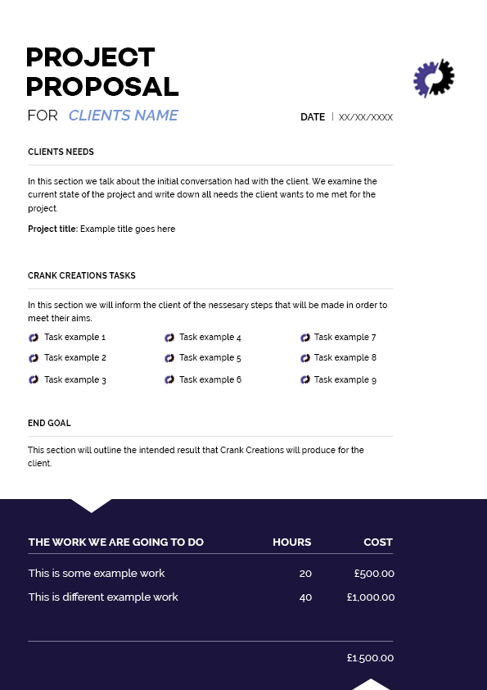

**Payment packages**

I decided to create payment packages to allow clients to choose the level of work/money put into their website. There will be 3 packages ranging from a 1 that would be a single page website to a 3 that will be a fully bespoke design. The biggest benefit from doing price packages is to allow the client to know the amount of money needed to pay for the amount of work they are wanting. This also prevents the client bartering with you or being unhappy with the result for the amount of money they paid. By doing the payment packages it cuts out any confusion between the customer and myself with regards to money and the amount of work. It also allows me to create fully bespoke websites and charge the correct amount. Whilst also letting the client visually see what additional features they will gain from paying more for this package by comparing to the other ones

Because I decided to add payment packages it allows the client to get a general price range for the package they decide to choose. Each price package has an estimated lowest and highest rate; their constructed quote will fit between those estimates. The payment is done in two instalments; half up front for safety precautions and half once the project is completed. This will be invoiced to the client once the: price, time and project scope have been arranged.

**Invoice**

An invoice allows the employee to send the client a breakdown of costs for the services/product provided. Below I have attached Crank Creations invoice template.

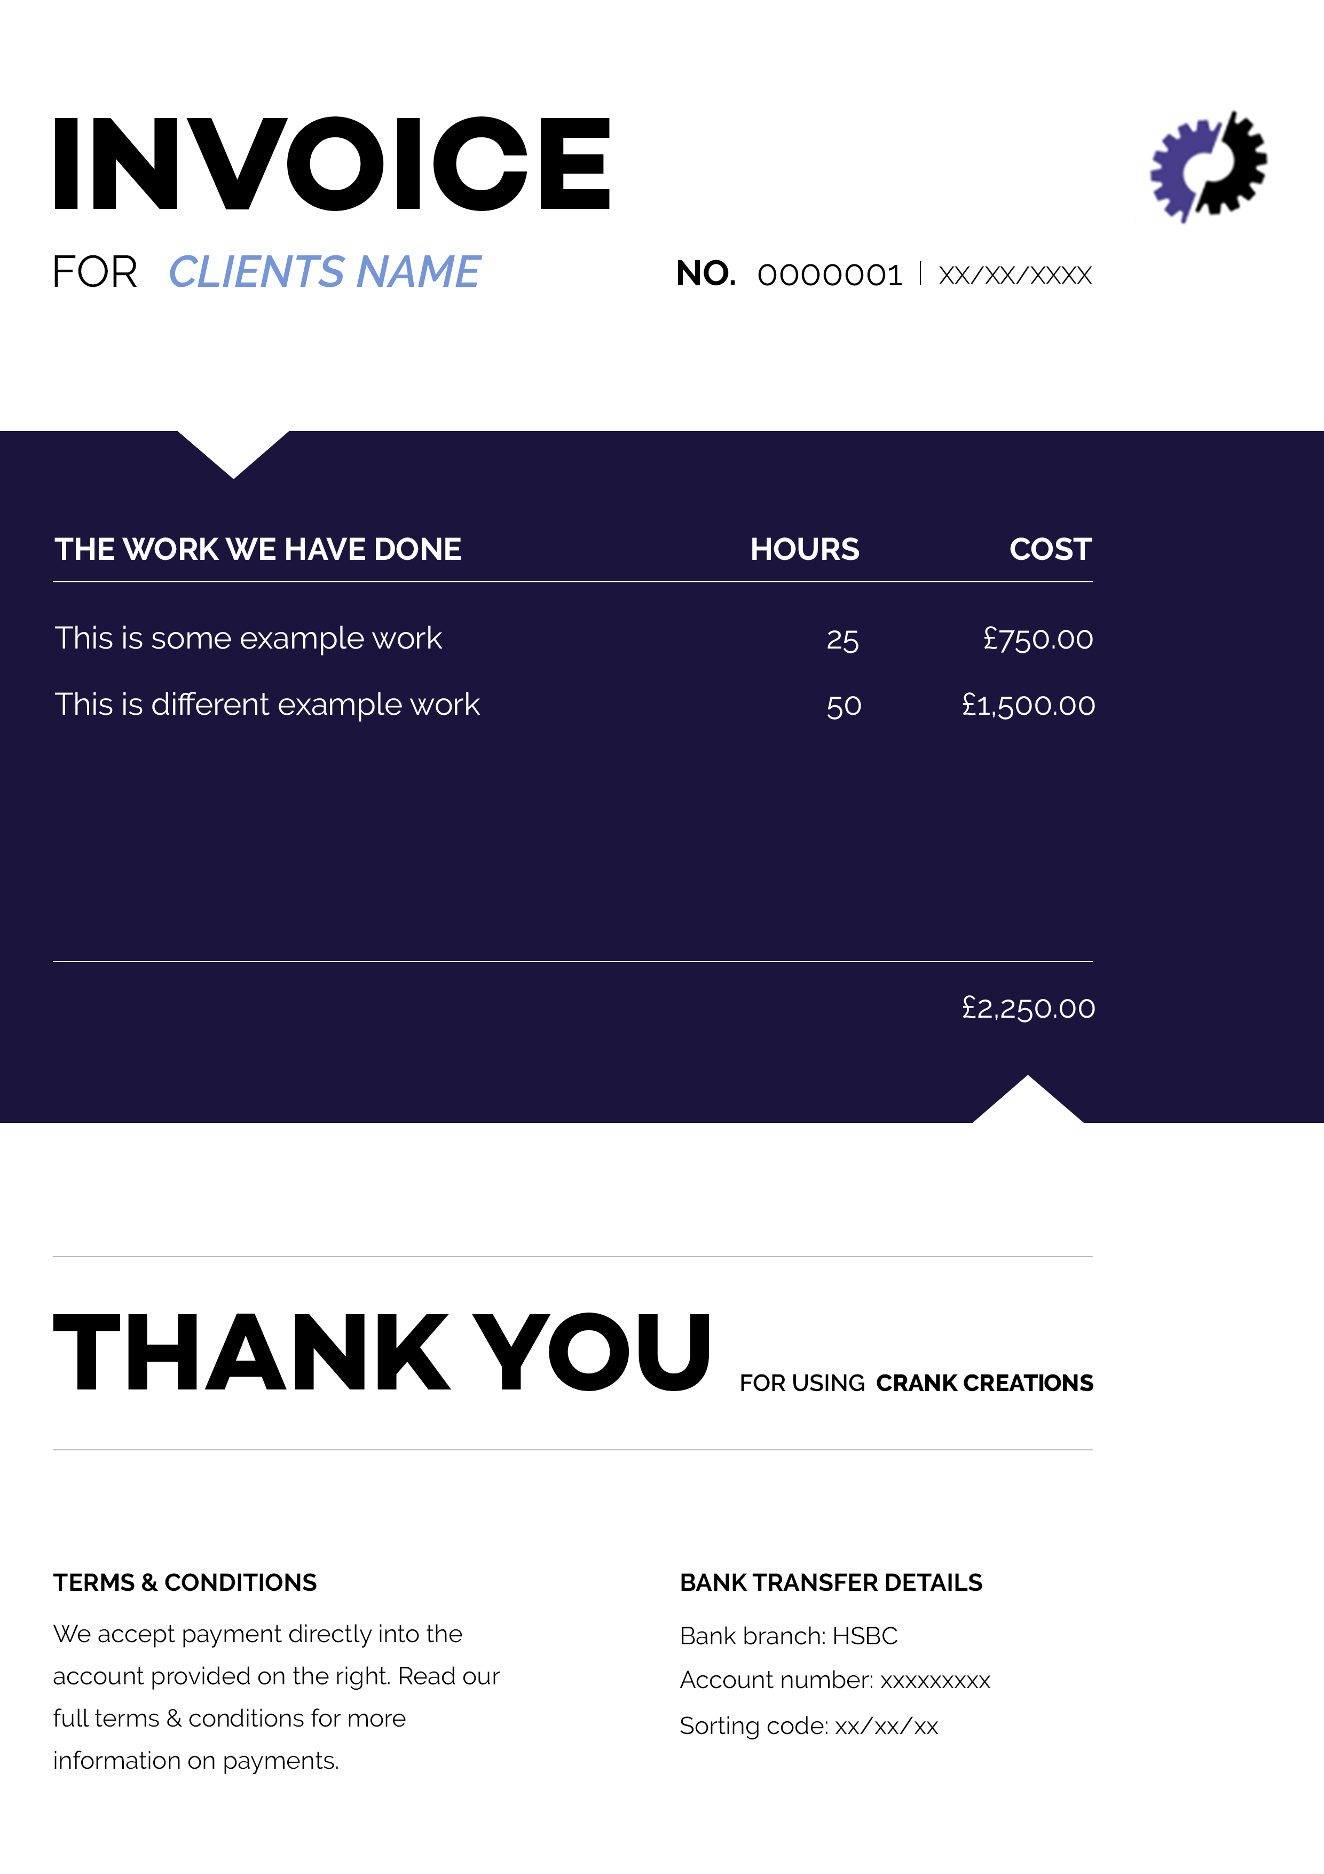

## 3.5 Registering my business

**Sole trader vs Limited company**

When setting up a business it is important to register your company as one of the following: a sole trader, limited company or business partnership. Due to the type of company I have created, the two I focused on were sole trader and limited company.

A sole trader means an individual runs the company and that person is self-employed. Having a sole trader company does not mean you have to work alone, you are able to hire as much staff as you want. Setting up a sole trader company is the quickest and easiest out of all of the options. Along with keeping records of your income and outgoings, the only documentation you need to deal with is sending a yearly self assessed tax return. Because you are solely responsible for the company, in the unlikely event that a client was to sue you, you would be held personally liable to settle that claim.[49]

A limited company can be run by multiple individuals, and the company itself is responsible in it’s own right for everything it does. There are a lot more conditions that need to be met before you are able to set up as a limited company, along with more documentation, such as: having at least one shareholder and one director, an address for the company, producing a statement of capital, producing an article of association and producing a memorandum of association. Certain documents are recommended to be completed by a professional accountant, meaning an annual spend from the company’s budget. Any profit that is made is owned by the company and then distributed accordingly (after tax). Because the money is owned by the company this means the individuals have more personal protection in terms of financial liability, meaning if your were to get sued as a company then the company’s assets would be liable and not your personal belongings.[50]

Due to the nature of my company I felt the likeliness of getting sued was very minimal. On top of this I believe the documentation and potential hiring of an accountant was unnecessary for this stage of my business. This is why I chose to set up my business as a sole trader company. Since doing this research gained a greater understanding about sole trader and limited companies. Because of this I estimated in the next 2-3 years I would be changing my business from a sole trader to a limited company.

## 3.6 Joining an association

**Wired Sussex**

Wired Sussex is paid membership organisation located in Brighton to help digital, media and technology companies to create, innovate and grow. There are many reasons why paying to join Wired Sussex is a beneficial investment. Being part of an organisation with over 2000 companies that are relevant to your sector, allows you to easily network with potential partners/clients to help your business grow. They provide a projects board that informs you of any work relevant to your company that may have become available. This project board also advertises individuals that you could potentially recruit to improve your business.[51]

Joining Wired Sussex I believe was a fantastic investment to help my business grow faster. By being a member it not only gives me a greater opportunity to improve my business and gain work. It also gives me a platform to network with other professionals to keep up to date with current affairs and new developments in the digital world.

## 3.7 Insurance policies

**Professional indemnity insurance**

Professional indemnity insurance (PI insurance) is a type of liability cover designed to protect an individual or business against claims made by clients for loss or damage due to negligent advice or services.[52] PI insurance will help my company in the unlikeliness of the client being unsatisfied with the product received and asking for compensation. I will not be using this insurance until my company grows in size and will have multiple projects in production at one time. This is because multiple employees will be working on projects simultaneously, so I cannot ensure mistakes are not made on every project. This insurance will cover the expenses if the customer’s needs are not met and they decide to ask for compensation.

**Property insurance**

Property insurance is a policy that allows reimbursement to the owner if their equipment is affected by: fire, water, theft, loss, accidental damage or a natural disaster.[53] By having property insurance it will reduce the impact my company will take financially from loss of equipment. It will also help cover compensation for clients if their information/work is lost. I will be looking into using property insurance at the early stages of my company. I will use one of the cheapest plans as the equipment I own is very minimal, which means I will not need expensive coverage.

## 3.8 Owning intellectual property

Intellectual property (IP) is every aspect of a product or service that enables people to earn recognition or financial benefit from what they invent or create, through patents, copyright and trademarks.[54] When creating a business it is very important to understand IP. This is because if either the client or anyone at your company breaks the law IP is protected under, the penalty could range from a polite letter asking the content to be removed to a jail sentence.[55]

My companies IP will be added to the terms and conditions that each client will receive and need to sign for the business transaction to proceed. I will be kept as the author and owner of IP for the website code created for each project. This is to allow small elements of code to be reused across projects, such as a contact form. Copyright, Design and Patent Act 1988 is the current UK copyright law that gives creators of artistic work the right to control the ways in which their material may be used.[56] The IP of designed assets for a client will be owned by my company to allow them to be displayed on websites as examples of work. As the designs will be bespoke I will ensure that the assets are not reused for other projects in the terms and conditions.

## 3.9 Site accessibility

When designing a website it is important to focus on making it accessible for all users. If it is not accessible to people with disabilities, you will lose a percentage of your target audience. The Web Content Accessibility Guidelines (WCAG) website was created to help web content get created that is accessible to people with disabilities. The WCAG is a technical standard that uses 12 guidelines to give your web page/application a testable success criteria to rate at either: A, AA or AAA.[57] The 12 guidelines are broken into 4 different principles: perceivable, operable, understandable and robust.

**Perceivable information and user experience**

This means the web page/application must be presented to all users in a way they can perceive it. So there must be no information on the page that a user would find difficult to read/understand. The perceivable principle has 4 guidelines to understand and implement.

**Text alternatives for non-text content**

This is ensuring an image, video, audio or function is labelled with text to help the user understand it. For example on a search button it will have the word “search” on it instead of a “magnifying glass”.

**Captions and other alternatives for multimedia**

Users that cannot hear audio or see video need alternatives to engage with the piece of media. For a user that is unable to see, the video should include audio descriptions that exaplains important visual details in the video. For users that are unable to hear the audio, they should be able to see sign language interpretations for the audio content.

**Content can be presented in different ways**

Allowing the content on the website to be presented differently by: allowing the user to increase/decrease the size of text, being able to change the colour scheme or any other change to the style to facilitate the user can improve the overall accessibility of your web page/application.

**Content is easier to see and hear**

There are many ways to make your web page/application easier to see and hear, such as: allowing text to be resizable, having a sufficient background and foreground colour contrast, not having colour as the only way of conveying/identifying information or having all audio able to be paused, stopped or turned off to reduce the chance of it interfering with assistive listening devices.

**Operable user interface from a keyboard**

The users must be able to effortlessly operate the web pages/applications interface. If there were operations that proved to be too difficult for certain users to complete, then this would result in a badly integrated user interface. The operable principle has 4 guidelines to understand and implement.

**Functionality is available from a keyboard**

Many users do not use the mouse when interacting with websites. To make the website accessible for these users, the content must all be accessible with the keyboard alone. Users might be using: keyboards with ergonomic layouts, on-screen keyboards, or switch devices. By having the content fully accessible to a keyboard it would improve the user experience.

**Users have enough time to read and use the content**

Some users may need more time when reading/using content. To ensure all users gain the full experience of a website, all content that changes should be viewable for an extended period of time. Ideally there should be no time limits for reading/completing contents or tasks.

**Content does not cause seizures**

Some users may have photosensitive eyes that when exposed to flashing light/images could cause seizures. To ensure this is not a problem it is important to avoid using any flashing content.

**Users can easily navigate, find content, and determine where they are**

A website that is well-organised and laid out helps users to navigate throughout effectively. The actions that could be taken to improve how users navigate through the website are: having clear page titles, multiple ways to navigate to each section, clearly labelled pages to ensure the user knows where they are and the purpose of a link is clear.

**Understandable information and user interface**

The content and operations on the website must be easily understandable to all users. By having content that is beyond the understanding of certain users would increase the chance of users potentially navigating away from the website. The understandable principle has 3 guidelines to understand and implement.

**Text is readable and understandable**

The content on a website must be readable and understandable to the broadest audience possible. The content must also be understandable for assistive technology.

**Content appears and operates in predictable was**

Many users rely on predictable interfaces that will stay consistent on each page. By ensuring the functionality of your website is consistent will help users feel comfortable when navigating though it. If the website is not consistent it could cause confusion to the user.

**Users are helped to avoid and correct mistakes**

It is important, when possible, to help users avoid making mistakes when interacting with the website, if mistakes are made then it is equally important to clearly label how the user can correct those mistake. For example when a user is filling in a form the instructions should be very descriptive. If an error is made on the form then the error messages and suggestion for correction should be clearly visible.

**Robust content and reliable interpretation**

By making the content of a website robust it would mean that users are able to easily access the content, even if technologies advance. Assisted technologies (text-to-speech programs, audio descriptor programs etc) are constantly evolving, by having a robust system that allows content to be accessible as these technologies evolve will greatly increase your websites overall accessibility. The robust principle has 1 guideline to understand and implement.

**Content is compatible with current and future user tools**

When creating your content you should ensure it is compatible with: all browsers including older versions, assistive technology and other user agents (a software that is acting on behalf of a user)[58]. By meeting this requirement it will help maximise compatibility with current and future user agents.

**Conformance levels**

The Web Content Accessibility Guidelines (WCAG) are divided into three conformance levels: A, AA and AAA. These levels are based on the design, visual presentation and overall accessibility of the web page/application. The higher the level the more restricted you are with your designs. This is because certain colours, layouts or fonts may be unreadable to certain users.   
  
**Level A** success criteria focuses on having a high impact on a large user population. This usually means not focusing on one type of disability. This level has the least impact on design for a web page/application.

**Level AA** success criteria meets all of the target users level A reaches but also aims to make the accessibility easier for specific user populations. This level may have impact on design for a web page/application.

**Level AAA** success criteria meets all of the target users level AA reaches but also focuses on improvements for the user population that have the most severe accessibility problems. This level will have a large impact on design for a web page/application.

**Accessibility for my website**

The accessibility of a website is very important when trying to cater for the broadest audience possible. After researching about The Web Content Accessibility Guidelines (WCAG) I realised that alterations needed to be made to ensure a large user population was able to use my company website.

The 12 guidelines stated by WCAG are key when designing the accessibility to your website. The main guidelines that I focused on were: text alternatives for non-text content, content can be presented in different ways (increasing size of text and different colour schemes), users can easily navigate, find content, and determine where they are, text is readable and understandableand users are helped to avoid and correct mistakes. By focusing on these guidelines it resulted in the company website being more accessible overall.

The conformance level I have aimed to achieve is a Level A – Level AA. This is because it will greatly increase the accessibility to a large user population whilst keeping design restraints to a minimum.

# 4. Business plan

**Business plan vs a start-up plan**

It is important for a company to have a document displaying their plans and goals for the future and how they look to achieve them. The two pieces of documentation I am looking to compare are a Business plan and a start-up plan.

A business plan is a formal document that states your goals, reasons they are attainable and plans for reaching them. It can also contain background information about the company and team. A business plan is a large document (average 20-40 pages) that is used to optimise growth and development by prioritising plans. However businesses that have not created one from the start commonly do when applying for business loans or investments. [59]

A start-up plan (aka Business plan canvas) is used to analyse an idea you would like to start a business with. It get’s you to think of the nine key components of an idea so you can decide whether you want to pursue it. It is also useful for those who have already started a business, as a concise business plan.[60]

From my research I decided to choose a start-up plan for this stage of my business. I will be creating a business plan at a later stage, however I believed a start-up plan is more than sufficient to portray the goals I am planning to achieve.

**Vision**

*If everything went to plan what would you consider your business to look like in the next 3-5 years?*

In 3-5 years I predict that my company will be working from an office located in Brighton. Crank Creations will be a limited company that has 4-6 other employees working on separate projects to maintain the companies’ successful reputation. Crank Creations will be a respected website design and development company that focuses on producing high standard websites to keep each client satisfied. The company gains a large amount of work through the recommendations of satisfied clients. The individuals that work at Crank Creations will be polite, helpful, disciplined and knowledgeable to make the clients project a straightforward and enjoyable process.

**Products and services**

*It is important to be able to explain the product/service you are selling.*

At Crank Creations we produce reasonably priced, high-quality, mobile responsive websites. We also provide an enriching service between client and employee, to plan and produce a user-friendly, modern and sophisticated website based on the clients wants and needs.

**Benefits and impact**

*How is your product/service going to add value to a client’s life or make it easier in some way.*

By producing a bespoke website for a client’s individual business/service, Crank Creations will be helping them to improve their reputation and company image that will enable them to branch out. It will increase the size of their company, which will also allow them to gain new employees and customers. It will make it easier to display their company information and the message they are trying to convey on an accessible platform to all.

**Customers and competitors**

*Work out who your customers are and research your competitors.*

Crank Creations target customers can be anyone. As a company we look to be as flexible as possible but to keep the client in mind to allow us to work with individuals, self-employed businesses and corporate companies.

For my competitor analysis I chose to analyse four different companies. Two of these were website design & development agencies, the others were freelance.

**Competitor analysis agencies**

**Build By Buffalo[61]**

Build by Buffalo is a Brighton based website design and development company. They have been around since 2006 and have grown drastically since then.

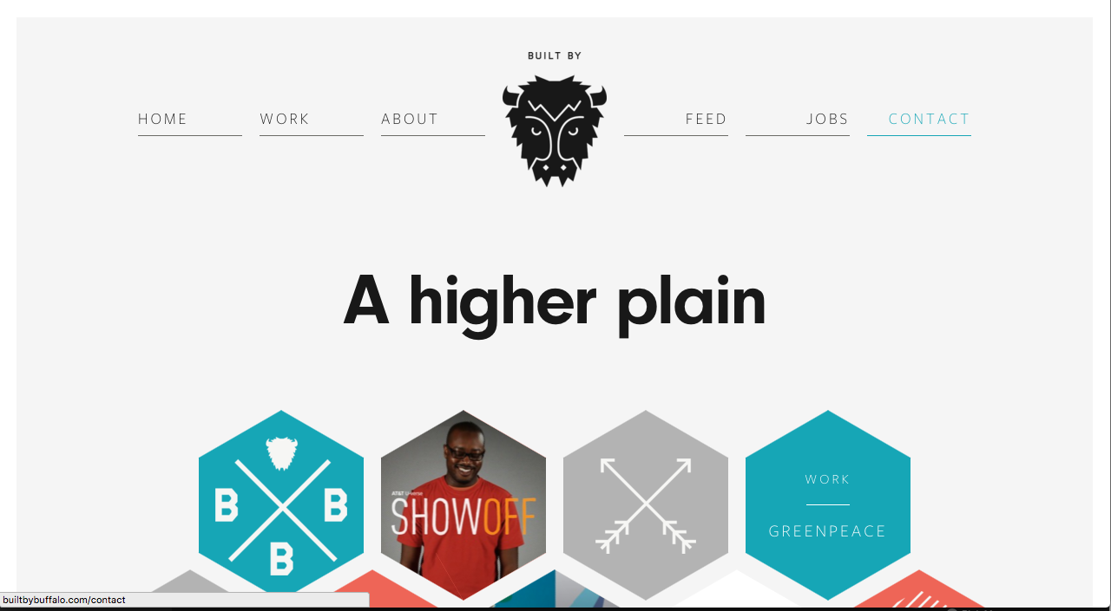

Built by Buffalo is a well-designed company that lets their client easily see the level of service they provide along with their skillsets.

The attitude you get from the website is the company are very laid back but with a great sense professionalism about them. This gives you the impression that communication with them will be easy and enjoyable but they will achieve the goals set out.

**Code 7[62]**

Code 7 is a website design and development agency located in Brighton. Like Built by Buffalo they were created in 2007 and have grown drastically since then. Ranking 1st in Google when searching for ‘website design and development in Brighton’.

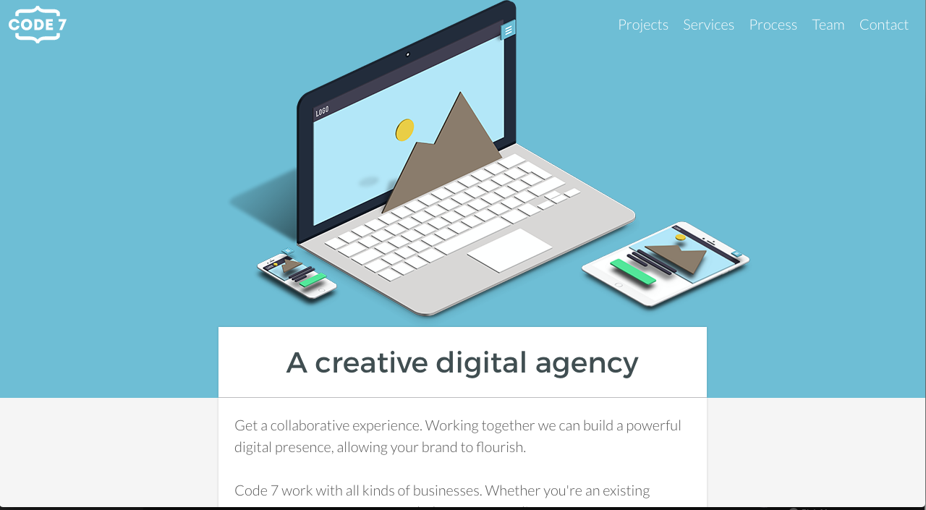

Code 7 are one of the leading website design & development agencies in Brighton & Hove. From the reviews I have seen on Google[63] Code 7 produce high quality work that satisfies their users needs. You can also see the impressive testimonials for specific projects on their website.[64] The design of their website does not appeal to me. However they have strong content, fairly good usability and enough respectable work in their portfolio to make them an extremely successful business.

Both Built by Buffalo and Code 7 are very respected digital design & development agencies In Brighton. They are direct competitors of one another in this sector and both advertise their company as creating great websites that are easy to use. When analysing these two agencies I could see they both had a very different approach; Built by Buffalo used a very clean and minimalistic style for their design and content. Code 7 used quite a busy design with lots of informative content throughout. Both have their advantages. Having a clean minimalistic design looks pleasant and allows the user to navigate through with ease. Having concise content means the user is more likely to contact Built by Buffalo regarding general questions, this will establish the first point of contact that could potentially turn into a lead through further communication. Having more informative content on the website can also be advantageous. The user contacting will be a stronger lead, as they would have learnt more about the business. This would result in their first point of contact being more qualitative, making them easier to convert into a lead.

To conclude, out of the two agency analysed my website will be more inspired by Built by Buffalo. This is because I will be looking to create a minimalistic design with subtle colours and a single deep accented colour. I will also be keeping the content concise like them. This is because I am going to be a new sole trader business with limited amount of portfolio work. So when a client contacts me regarding a question, I will have a better chance of converting them into a lead through communication.

I have created a table to show how I have rated these two design & development companies on a scale of 1 to 10. The results have been created from the information I gave in the competitor analysis and displayed in a table and radar graph.

|  |  |  |
| --- | --- | --- |
|  | **Built by buffalo** | **Code 7** |
| Quality of branding | 9 | 7 |
| Structure | 7 | 7 |
| Content | 6 | 7 |
| Landing page | 7 | 5 |
| Logo | 7 | 7 |

**Competitor analysis freelancers**

**Design Superheroes[65]**

Design Superheroes is a freelance ltd website design and development company located in Brighton & Hove. It is a highly ranked website on Google when searching for “Freelance designer & developer in Brighton”.

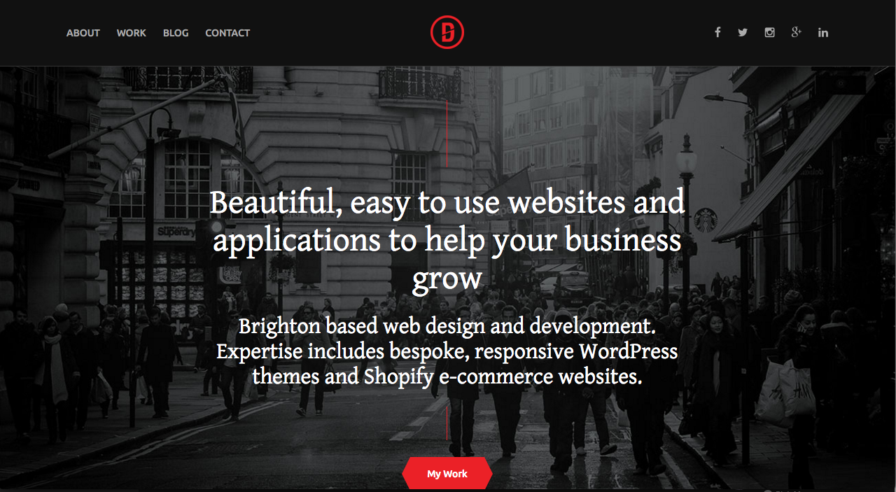

Design Superheroes is a great example of a freelance website done right. The design stands out whilst looking pleasant. The user experience allows for a great journey around the website. The development is clean and efficient and most importantly the branding and content is very personal. This really gives you the sense that working with this company will be an enjoyable experience.

**Roweena[66]**

Roweena is a freelance website design and development company is Brighton.

They rank 1st on Google when searching “Freelance website design development Brighton”.

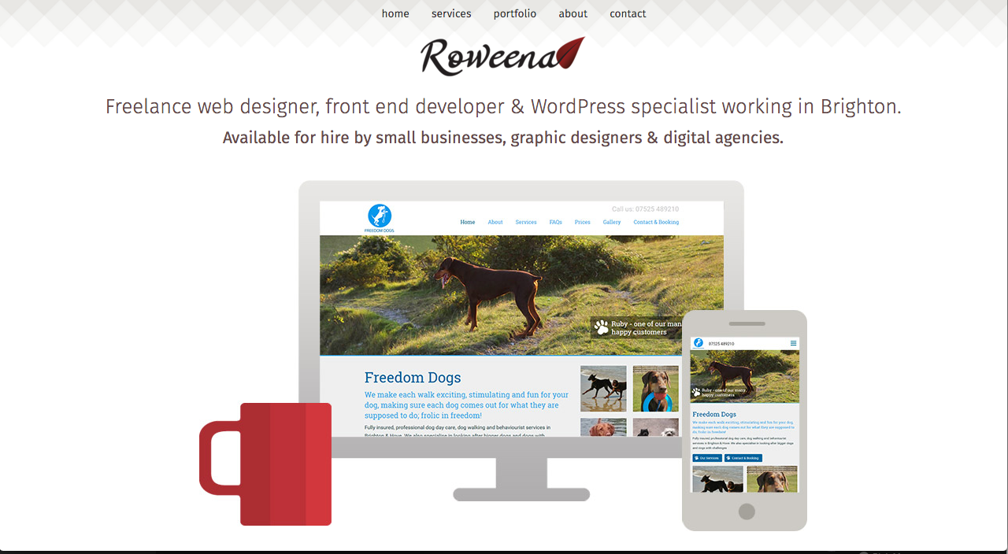

Roweena is a good freelance website that displays their content well. I personally dislike the design aspects of this website as I believe it is boring and lacks personality. The content is concise and explains what is needed, however it does not give away any personality of the individual or the company.

Both freelance companies have very different approaches to appeal to their target audience. Both structure their website different but individually very well. They each have concise content with very different messages being interpreted. Simple and minimalistic is the design they both strived for, however I felt Design Superheroes’ website flowed nicer and had a harder impact on me. In conclusion I learn a lot from analysing these two freelance companies. I gained a better understanding of how a minimalistic design can flow and stand out better than others. This is achieved by using 3-4 colours and making the copy, icons and buttons a vibrant colour compared to the simple coloured background. Making sure the structure of my website is easily accessible and the usability is simple and pleasant. This will be tested once my business website has a prototype to user test. One of the most important aspects I learnt from this analysis is the personalisation of a freelance website. After viewing Design Superheroes it influenced me to make my business website slightly more personalised. It will not have as much personal information as Design Superheroes, however it will have more than Roweenas. This is because Design Superheroes has a large portfolio of work, whereas I will not at the beginning stages of my business so will not want to take away from the professionalism of my company. When working with a client sometimes you want to show them a small insight into your personal life. This could allow potential customers, when browsing my website to get more familiar and accustom to my personality and values. Resulting in a client who would feel more comfortable contacting me as it attaches a real person to a website and brand.

From the information I have gained from this freelance individual competitor analysis, I will be able to rate the two freelance companies on a scale of 1 to 10. Below I have displayed the information gained in a table and radar graph.

|  |  |  |
| --- | --- | --- |
|  | **Design Superheroes** | **Roweena** |
| Quality of branding | 9 | 4 |
| Structure | 7 | 6 |
| Content | 9 | 7 |
| Landing page | 8 | 6 |
| Logo | 7 | 7 |

**Marketing activities**

*How to inform customers about the service/product you are offering and encourage them to buy it.*

Crank Creations business website will hold all of the information necessary for a client to be informed of our service and product. The SEO on the website will be optimised to help potential clients searching for a website designer be able to easily find the business website through Google. Using social media as a platform to market allows you to gain a lot more potential clients. Once a few projects have been created, those clients will market our service and product through word of mouth.

**External environment**

*What’s happening on a local, national or international level that is going to impact your business both positively and negatively.*

I have decided to create a PEST analysis diagram for my business. This is to understand the environmental factors I need to take into consideration for my business market. It is a useful strategic tool for understanding market growth or decline, business position, potential and direction for operations.[67]

|  |  |
| --- | --- |
| **Political**   * Government stability * Government policies * Future legalisations * Regulatory bodies and processes * War and conflict | **Economical**   * Inflation * Unemployment * Monetary issues * Increase/reduction in labour costs |
| **Social**   * Attitudes to work and leisure * Health and lifestyle * Social mobility * Clients attitudes and opinions * Change in demographic | **Technological**   * New technological discoveries * Rates of obsolescence * Rates of development * Licencing/ patents * Research showing new current web trends |

**Operations and risks**

*Think about exactly how you plan to run your business. What facilities and equipment will you need.*

In the early stages of my business I will need a computer/laptop and telephone as equipment to successfully run Crank Creations. I will be working from home and set up as a sole trader. As the business expands and evolves the amount of equipment needed will increase and my facility and legal status will change. I will be set up as a limited company and look to purchase an office space to work from. The equipment needed to run a business would be increased to compensate for the: change in workspace, increased number of staff, larger projects being worked on and evolutions in technology e.g. new computers.

**Me and my team**

*In order to run your business or progress with your idea, how many staff are you going to need?*

Initially all the company tasks will be undertaken by myself, however once the business begins to grow, staff will be employed to help manage the increasing number of projects. Those rolls consist of: managing the finance of the business, design work for projects, development for projects, marketing of the business and initial communications to source projects. In total a team of 4-6 would be ideal for the successful running of my business.

**Costs and income**

*1How much will it cost you to run your business on a: monthly, 6 monthly or yearly basis.*

I created a cash flow forecast and survival budget to accurately estimate my income and outgoings for the next 6 months. By creating this document I could plan in advanced for any shortage of money, to prepare myself if it were to happen. By rounding up your expenses and rounding down your income it can allow you to prepare for the worst-case scenario.

The difference between a cash flow forecast and a survival budget is a survival budget is focused on expenses for your personal life, for example: meals out, clothing and food shopping. A cash flow forecast focuses on the expenses that are compulsory for running a business, for example: living accommodation bills, rent and your mobile phone bill.

**Cash flow forecast & survival budget**

*The table below is a combination of a cash flow forecast and a survival budget.*

|  |  |  |  |  |  |  |  |
| --- | --- | --- | --- | --- | --- | --- | --- |
|  |  |  |  |  | **Month / 2016** |  |  |
|  |  |  |  |  |  |  |  |
|  |  | **March** | **April** | **May** | **June** | **July** | **August** |
| **Income** |  |  |  |  |  |  |  |
|  |  |  |  |  |  |  |  |
| Jamie’s Rent |  | £250.00 | £250.00 | £250.00 | £250.00 | £250.00 | £250.00 |
| Jemma’s Rent |  | £250.00 | £250.00 | £250.00 | £250.00 | £250.00 | £250.00 |
| Student finance |  |  | £2,900.00 |  |  |  |
| Web design/development work |  |  | £650 |  |  | £1,000.00 | £850 |
| **Total Income** |  | £500.00 | £4,050.00 | £500.00 | £500.00 | £1,500.00 | £1,350.00 |
|  |  |  |  |  |  |  |  |
| **Expenses** |  |  |  |  |  |  |  |
|  |  |  |  |  |  |  |  |
| Gas & Elec |  | £15.24 | £15.24 | £15.24 | £15.24 | £15.24 | £15.24 |
| Water |  | £6.34 | £6.34 | £6.34 | £6.34 | £6.34 | £6.34 |
| Broadband |  | £7.50 | £7.50 | £7.50 | £7.50 | £7.50 | £7.50 |
| Rent |  | £500.00 | £500.00 | £500.00 | £500.00 | £500.00 | £500.00 |
| Mobile phone |  | £15.00 | £15.00 | £15.00 | £15.00 | £15.00 | £15.00 |
| **Total Expenses** |  | £544.08 | £544.08 | £544.08 | £544.08 | £544.08 | £544.08 |
|  |  |  |  |  |  |  |  |
| **Survival budget** |  |  |  |  |  |  |  |
|  |  |  |  |  |  |  |  |
| Clothing |  | £30.00 | £30.00 | £30.00 | £30.00 | £30.00 | £30.00 |
| Food and housekeeping |  | £150.00 | £150.00 | £150.00 | £150.00 | £150.00 | £150.00 |
| Hire charges |  | £15.00 | £15.00 | £15.00 | £15.00 | £15.00 | £15.00 |
| Subscriptions |  | £22.50 | £22.50 | £22.50 | £22.50 | £22.50 | £22.50 |
| Entertainment (meals and drinks) |  | £100.00 | £100.00 | £100.00 | £100.00 | £100.00 | £100.00 |
| Children expenditure and presents |  | £20.00 | £20.00 | £20.00 | £20.00 | £20.00 | £20.00 |
| Travel |  | £50.00 | £50.00 | £50.00 | £50.00 | £50.00 | £50.00 |
| **Total Survival Expenses** |  | £679.08 | £679.08 | £679.08 | £679.08 | £679.08 | £679.08 |
|  |  |  |  |  |  |  |  |
|  |  |  |  |  |  |  |  |
| **Total Expenses + Total Survival Expenses** |  | £1,223.16 | £1,223.16 | £1,223.16 | £1,223.16 | £1,223.16 | £1,223.16 |
|  |  |  |  |  |  |  |  |
|  |  |  |  |  |  |  |  |
| **Net Cash Flow** |  | -£723.16 | £2,826.84 | -£723.16 | -£723.16 | £276.84 | £126.84 |
|  |  |  |  |  |  |  |  |
|  |  |  |  |  |  |  |  |
| **Monthly Opening Bank Balance** |  | £94.36 | -£628.80 | £2,198.04 | £1,474.88 | £751.72 | £1,028.56 |
|  |  |  |  |  |  |  |  |
|  |  |  |  |  |  |  |  |
| **Cash Position** |  | -£628.80 | £2,198.04 | £1,474.88 | £751.72 | £1,028.56 | £1,155.40 |

# 5. My company

## 5.1 Company name

**Majime studio**

When I was choosing a name for my company I wanted to have one that was unique and memorable. Majime is a Japanese term that signifies being responsible, reliable and getting things done without drama.[68] It is also an anagram of Jamie M. When searching domain names for my company I found that Majime studio was taken, along with: Majime design, Majime development and Majime. I wanted my company name to have an impact when first said to someone. I believed Majime studio had that impact. The main problem I found with Majime is how people would both pronounce it, and interpret how it’s spelt. This could be a large problem when explaining your business to someone and they return home realising they are unsure how to spell your company name.

**Crank design & development**

I decided against the company name Majime. The main reason being it was hard for people to pronounce correctly, especially when read.

Instead I wanted to name my company “Crank”. I believe with the correct icon, typography and colour scheme this could work very nicely. A crank is most commonly known as a piece of equipment that fits between parts of a machine to create movement. The reason for choosing the word crank is because it represents my website design and development company. My company will act as the crank between the clients and the final product. It is a concise company name that will scale well. A key aspect of a company name, I believe, is to ensure the company can be represented with just the icon within the logo. It proves the design is eye catching and memorable.

**Crank Creations**

After creating the logo for Crank design & development I realised the name was too long and didn’t have the initial impact I wanted when explaining to someone. There were no ‘.co.uk’ or ‘.com’ domain names available for Crank design or Crank development (having Crank design & development was too hard to understand without spaces in the URL). I decided to change the company name to Crank creations. Crank creations is a lot easier to remember and understand, especially when written in a URL. I was able to purchase a ‘.co.uk’ and ‘.com’ domain name for crank creations. When explaining the company to individuals I believe Crank creations has a unique but relevant name linking the creations part to the deliverables getting produced.

## 5.2 Company logos

Below I have the final designs for each company name along with the changes made between each one (*For the full logo design process see Appendix 1.1)*.

**Majime studio**I wanted the logo for Majime Studio to have clean and easy to read text with a vibrant icon logo. This is to allow the shorthand icon to be recognised on it’s own without the need for the title.

**Final design**

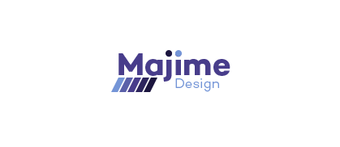

**Crank design & development**

I wanted to use the accented colours from my website. The colour was between purple and blue. Blue represents creativity, being imaginative and wise. Purple represents trust, being dependable and strength.[69] All of these traits are what I want the user to feel when viewing my company website.

**Final design**



**Crank Creations**

The style of logo was very similar to Crank design & development. I decided to keep the font lowercase with the first letter of each word capitalised. This is because it made it easier to read and became a more subtle logo.

**Final design**



## 5.3 Company colour scheme

During the creation of the company logo I discovered that I wanted to use the colour blue or purple as the accented colour for my company. I decided to choose purple for the logo, however I still want to use blue within my company because studies show it represents creativity, being imaginative and wise[70]. Colours psychological meanings differ depending on the person but generally purple and blue represent trust and creativity. I created a colour palette to give myself a visual example of the colours that will represent my company, mainly on the website.



I will explain roughly where each colour in this palette will fit into the website (from left to right). Colour 1 will be used for subheadings. Colour 2 will be used as the accented colour for icons and occasional headings. Colour 3 will be used as the background colour. Colour 4 will be used occasionally for headings and as the footer background above the copyright information; this will be where contact information will sit and links to social media on each page. Colour 5 will be primarily used for body text, it will also be used as the copyright footer background.

The website will be very clean and minimalistic. Using a predominant amount of colour 3 with colour 1, 2 and 4 subtlety used throughout will do this. I believe this colour palette will make my company website look slick and modern. Whilst also being minimalistic and eye-catching. These are the main positive points I realised from the competitor analysis that I personally thought would make for a great website design.

## 5.4 Company layout ideas

The layout of a website is very important. The user must be in mind during the whole process. This is to ensure the website is user friendly. Making the website user friendly is a key aspects in the design process. If a user cannot operate the website as intended, then that user may choose to navigate away from your website (*For the full list of layout designs see Appendix 1.2)*

## 5.5 Company assets

**Icons**

I created bespoke designs for each icon used on the company website. Each icon must look unique whilst still portraying the section it covers.

**Strategy**

When creating a strategy for a project you must plan each operation well. If a task is poorly planned, it could potentially hinder future tasks that may depend on it. This reminded me of building blocks. If the foundation is poorly executed it will only cause trouble as the blocks stack higher.



**User experience**

The user experience of a website is how well the user interacts with it. For the icon I decided to create a three column wireframe of a website. This demonstrates a clean interface wireframe that would be easily accessible for users.



**Design**

The design of a website is everything visually displayed on it, such as: colour scheme, graphical designs and layout. When creating the icon for design I thought of a paper aeroplane. This is because everyone has his or her own favourite design for one. Some are more commonly known due to best practise, but when creating a paper aeroplane it really does come down to preference, like designing a website.



**Development**

The development of a website is the code used to produce everything seen on a website. I decided to make the icon for development be two brackets and a forward slash. This is a term very commonly used in HTML (the markup language used to display a website).



**E-commerce**

E-commerce (electronic commerce) means commercial transactions conducted electronically on the Internet. When creating an icon I chose to design a shopping cart. This is because it is a widely acknowledged icon to represent shopping, whether online or offline.



**Content management**

Content management is the way any content is organised. In terms of websites it means the storage (hosting) of the code and assets. This is most commonly done on a content management system. This is the reason I chose to use an abbreviation of the term content management system as my icon.



**Illustrations**

For certain pages throughout the website I created animated illustrations. Each illustration was either a gif animation, complimented by CSS animations or animated itself with JavaScript *(For the fulls breakdown of each illustration, see Appendix 1.3).*

**Homepage**

On the homepage for the Crank Creations website I creating two illustrations, one is a gif animation with css3 animation around it and the other is a static illustration.

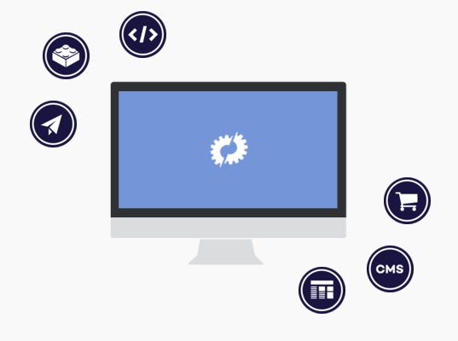



**Contact page**

On the contact page for Crank Creations I produced a simple gif animation to make the page more exciting.

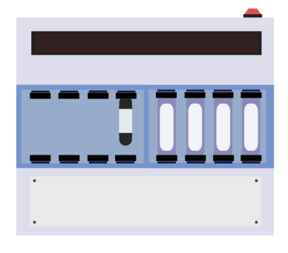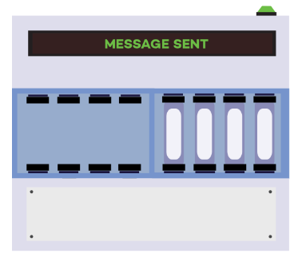

**About page**

On the About page I created two simple illustrations, one was a four sectioned cog that once clicked displayed the four key points that make up a Crank Creator. The other was a simple heart with a crank in the middle.

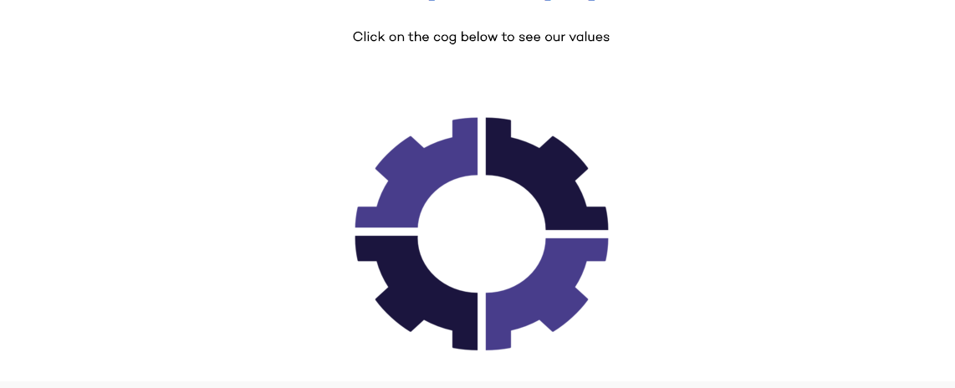

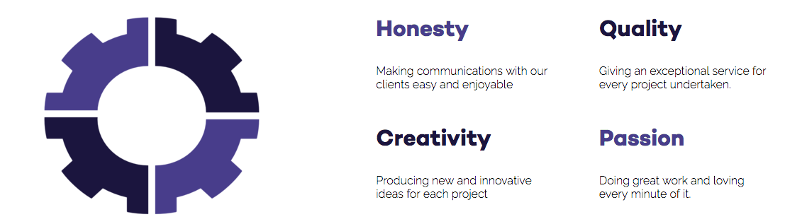



## 5.6 Company business cards

Company business cards are a fundamental way to market your business through person to person networking. When designing the business cards it is important to keep to your branding and display all the relevant information a client might want to see about you and your business.

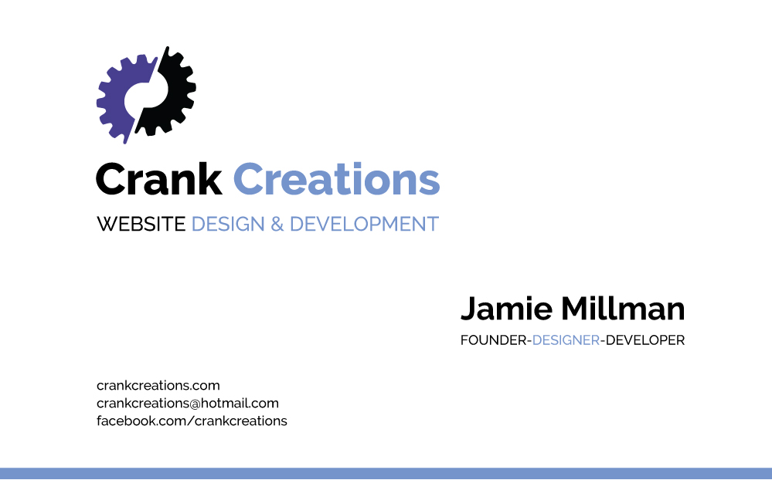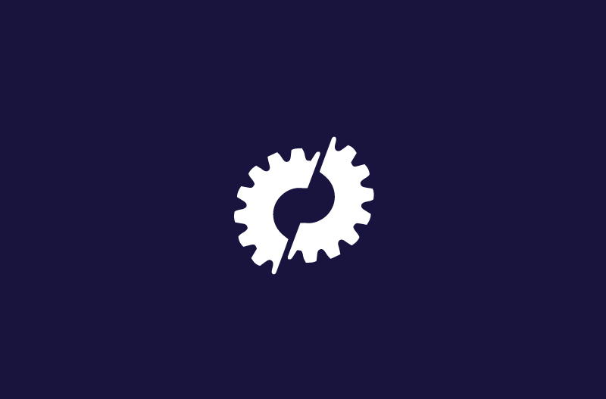

## 5.7 Company fonts

**Heading font**



The font used for the heading elements on the company website is called Campton. Campton is clean san-serif font that looks great in both bold or light font weight. For the heading elements Campton was used specifically in the bold format. This was downloaded for free from the website font fabric[71]. I then made it into a web font through font squirrels web font generator[72]. Font squirrels web font generator is a service provided by font squirrel that allows users to convert a standard font format (.ttf, .otf, .eot etc.) into a web font. This allows standard fonts to be used in the development of websites by creating a HTML and CSS file for them, that you copy into your code. Certain fonts are blacklisted from this service, so you must make sure the font can be used for web before converting it.

**Body font**



The font used for the body elements on the website is called Raleway. It is a simple, thin and clean san-serif font that works well as a thin weighted body font.

This font was used from Google web fonts [73]. Google web fonts is a website that allows you to effortlessly find a new font to add to your website. Once you find your desired font, you can choose to either: copy and paste a line of HTML code to put into your HTML document, import the font by using either SASS or LESS or add it using JavaScript. I imported mine using SASS because it was the neatest and most efficient way to add it, for example the HTML code must be added to every HTML page that requires the font. Once it is correctly linked to the website, you then add a small line of CSS for each element you want styled as that chosen font.

**Font stack**

When using a downloaded font it is very important to have fall-back web safe fonts in case the users browser is unable to render/use the font. This process is called a font stack. For example if the HTTP request for the font file times out, it will corrupt the font, rendering it useless at that time. This is why having web safe fonts as a fall-back is important to ensure all users have a similar experience on the website.

**Testing font across browsers**

Once the website was finished I began testing across all browsers to see if the fonts were rendering correctly. The browsers I was able to download onto my computer for testing were: Google Chrome, Mozilla Firefox, Safari and Opera. Each one was the most recent version and my fonts all rendered correctly. I was unable to download Internet Explorer or test on older version browsers, so I used a website called Browserling to help test my fonts on these platforms.  
  
Browserling is a web application that allows you to enter your websites URL and it will virtually run it in your chosen browser. I checked my company website in every browser up to 5 versions old. This is to ensure clients that do not regularly update still get a similar user experience. It also allows you to test different versions of android OS browsers. [74]

# 6. Evaluation

To conclude this report I will now evaluate the three main stages of creating my business, research, the products and marketing. I am going to explain what I learnt during these stages and outline the strengths and weaknesses from them.

## 6.1 Analysis of the research

**Introduction**

Before creating the business website and business cards, it was imperative to have done extensive background research on competitor companies and common trends in the web industry. This was to ensure the decisions I made were justified by the research I had compiled.

**What I learnt during and did it meet it’s aims**

By evaluating the research stage I am able to see if each aim was met and if it wasn’t then why. This will allow me to judge the success of each aim in the research stage, to then conclude with what I would of done differently in hindsight

By analysing the current state of the digital industry that I am creating my business into, I was able to greatly improve my knowledge of the sector and learn about interesting articles focusing around the creation of a business, such as the Lean Startup and The Brighton Fuse. After gaining some knowledge on the digital industry, I was then able to transfer that knowledge into focusing more on the website design & development industry, whilst keeping the same business approach.

I then proceeded to contact respected digital agencies located in Brighton and London to ask them about the tools they commonly use to help in the daily running of their business. After the information gained from the digital agencies along with my personal research, I gained a strong understanding of the tools commonly used in the industry and which ones I would select for my companies toolkit.

I then proceeded to research the accessibility of websites. The 12 guidelines stated by The Web Content Accessibility Guidelines (WCAG) helped me understand the necessary steps needed to improve the accessibility of a website. By choosing from the 12 guidelines it allowed me to select the points that gave my website a basic accessibility level without impeding the design too much.

The knowledge I had on the inner workings of a business was very limited before starting this project. I am now competent in knowing the correct method of running a small web business, from setting up insurance policy, legal status’s and terms & conditions, to producing a business start-up plan and the common operational procedures.

**What I would of done differently in hindsight.**

There are certain aspects that I would of done differently during the research stages if it wasn’t for time constraints and lack of previous knowledge. I would have liked to ask more companies about their toolkits. I currently had 3 companies that responded to my emails and they reinforced a lot of the ideas I originally had from my research on toolkits. If I had more example companies it could of potentially increased my overall knowledge of tools in the development industry. I could have increased my company research scope to worldwide, to get a broader understanding of the tools and techniques used globally, allowing me to cater better towards potential customers around the world.

## 6.2 Analysis of the products

**Introduction**

The business website and cards were the deliverables produced from the knowledge gained during the research stage of the project. When creating the website and business cards it was important to focus on using the experience gained from the research stage to guide the decisions made when designing and developing.

**What I learnt during and did it meet it’s aims**

Evaluating the deliverables of this project will help show the task undertaken to improve my skills in various computer languages and programs used during the design & development stage of the business website and cards.

When creating the company website, it was important for me to have a thorough understanding of the tools being used in my company toolkit. I have not previously used any of the tools listed in my toolkit (excluding JavaScript and jQuery) so it was challenging to gain a deep understanding of so many different tools during the project. Since the production of my website I have become confident using these tools and my strength with them will continue to grow the more projects I complete.

When creating the bespoke icons and illustration for my business website it allowed me to vastly improve my Adobe Photoshop and Illustrator skills. Having improved knowledge of these programs will help me with any project needing bespoke assets created for a client. Creating and implementing a gif animation to then edit with CSS and JavaScript was a task I have never undertaken before. I believe it to be an effective form of animation whilst also keeping the loading time to a minimum.

During the research stages of my project I decided to focus primarily on JavaScript and try to avoid the use of jQuery throughout. During the development of my company website this proved to be the incorrect approach. jQuery’s syntax is different to JavaScript’s (even though it is a JavaScript library), this was one of the main deterrence’s of learning to use it. However certain tasks can be achieved a lot simpler with one as apposed to the other. This showed me that having a general understanding of both would prove to be more beneficial for the future.

Creating the business cards for my company helped further my knowledge in Adobe Illustrator CS6. I have never created business cards before, however I am now competent in doing so for the future.

**User test results**

The reception received from the usability test was very positive. Points were made throughout the process of the usability test that I had either forgotten to implement or did not think to. These justified critiques helped me outline sections of my website that needed to be improved to further enhance my companies websites functionality and usability. The positive feedback reassured me that the planned decisions made in the research stages were the correct ones. This resonated through the participant’s structured analysis.  
*(For the full usability test see Appendix 2)*

**Client websites**

I have worked on two client websites since the creation of my business. One was a company I approached for a full redesign of their current website. The other was a student at the University of Brighton that approached me after viewing my companies social media and website. I have fully created the students blogging website and the re-design job is currently still on going. From these results it has shown my company has been successful and already gained work from it.

**What still needs to be done with the products**

In the future I will increase the conformance level of Crank Creations website. This will be achieved by focusing on more of the 12 guidelines. This will involve restricting design aspects to compensate for the improved accessibility. Once I have more projects, I will add functionality to the work page so the user is able to filter the work page to only show specific projects relating to that filter. These filters could be sectors, package type or both. I will potentially add a new section to help differentiate between a strong or weak lead. I will keep a simple contact form but add a sophisticated project planner section that allows the user to fill in drop down fields to select a type of project they are looking to produce. This will gain me more qualitative information on the clients needs and help manage strong and weak leads.

I have not completely finished the re-design project for Speak the Speech [75]. This is a task that will be continues and finished after this project has finished.

## 6.3 Analysis of the marketing

**Introduction**

Once the research and deliverables were created, the next step was marketing the business. This was an important task to ensure the company created was then correctly advertised and distributed to allow the right clients to begin contacting you.

**What I learnt during and did it meet it’s aims**

There is no end to marketing a business; it is an on going task to ensure your business gets portrayed correctly to its target audience. As times change marketing techniques will be constantly evolving. However for the scope of this project I was able to set up the marketing for my completed business to have a powerful online presence through social media and Google (with onpage and offpage SEO). I also created fully branded business cards to give to potential business links and clients.

Marketing a website with on-page and off-page SEO (Search Engine Optimisation) was a task I had never previously undertaken. The on-page SEO for my company website is very important when Google is looking for key words to know how to display my company. In the: page title, meta description, meta keywords, body text and heading tags it is important to use keywords that define your company. The keywords I commonly used for these sections were combinations of: web, design, development, brighton, cms, e-commerce and crank creations. With the combinations of these keywords throughout my website in my meta data it will help Google display my website when users search for similar keywords. The off-page SEO of my company website is important to help improve the overall Google ranking of my website. By acquiring highly rated search engine result pages (SERPs) to link to your website will improve your websites overall ranking. I have three separate social media pages (Facebook, Twitter and LinkedIn) that link to my company website. Sam from Bee Purple (Brighton Universities entrepreneurial network) offered to host my company website on their business directory page [76]. This was to help with my companies rating. Because this is a‘.ac.uk’ website it is highly respected by Google and will further improve my overall rating.

After researching the best social media platforms for a web business, I decided to focus on three of the four platforms analysed; Facebook, Twitter and LinkedIn.

After setting up Facebook, Twitter and LinkedIn I then proceeded to populate each page with the company’s information. This information included my company email, which is currently set to a ‘@hotmail.com’ extension. This will soon become a ‘@crankcreation.com’ email address to look more professional. This will be achieved by setting up a professional email with my web hosting provider. Another important part of information on the social media pages is the link to my company website, this will give my social media audience the opportunity to easily view my company website, potentially gaining more clients.  
Once each page was set up, I then began to invite family, friends and colleagues to view my pages to help spread information about my company. I have been regularly posting interesting content on each platform to ensure I keep my audience satisfied so they will like posts I share, in result displaying them to their connections.

By creating business cards it allowed me to distribute the information about my company in person to individuals that may be interested. This is a great way to market my company by word of mouth and allow them to easily access the information I explain to them.

**What still needs to be done with the marketing**

As stated before, marketing is a constant task during the running of a business. Looking back at my project there were certain tasks I believe would of helped with the overall success of the business. A social networking group in Brighton called ‘The Farm’ hosting casual meet-ups weekly. If you were a regular member of this meet-up you would get a page on their website, where you could have a backlink to your company website and social media pages. Unfortunately I did not attend this meet-up due to time constraints, however I will begin to after University. I did not market my business on YouTube at this stage of my business. This was to ensure I took my time creating the correct content that users would enjoy. With every finished project I will learn how to use new languages, platforms and software’s that I will be able to share with my users, in the form of tutorials, best practice or simple informational videos. This is why I have chosen to postpone using YouTube until later on in my business. I will update my email address to have an ‘@crankcreations.com’ extension, this will involve redesigning my business cards to fit the correct content.

**Conclusion**

To conclude I have successfully researched, planned and created my own website design and development company, Crank Creations. In order to do this I learnt: the current web trends, tools and languages used at common design & development companies that I later learnt how to implement them myself; how to market a newly created business through social media, business cards and SEO; how to correctly produce and cater business documentation to successfully and legally run a business; and how important it is to network at conferences, workshops and events to help gain potential clients or business associates.

This project was initially conceived to utilise all of the skills previously learnt over the years spent at University. By creating this project it allowed me to demonstrate the vast array of skills I have gained and have a platform to pursue my chosen career once I have finished University.

**LAST POINTS** I need to mention about all of the last points in the report (bits from student central) in my evaluation e.g. talk about the technical grasp of this project.

**TECHNICAL GRASP**

**UNDERSTANDING OF PROBLEM AREA**

**PROJECT MANAGEMENT**

**REPORT QUALITY**

**EVIDENCE OF LEARNING**

**RESEARCH EFFORT**

# 7. Bibliography

Siltala, M. (2013). *Color Emotion Guide.* Available: http://visual.ly/color-emotion-guide. Last accessed 29th Nov 2015.

Strategyzer. (2015). *The Business Model Canvas.* Available: http://www.businessmodelgeneration.com/canvas/bmc. Last accessed 23rd November 2015.

Ciotti, G. (2013). *The Psychology of Color in Marketing and Branding.* Available: http://www.helpscout.net/blog/psychology-of-color/. Last accessed 30thv November 2015.

Sass. (2006). *CSS with superpowers.* Available: http://sass-lang.com/. Last accessed 4th Dec 2015.

Coyier, C. (2012). *Poll Results: Popularity of CSS Preprocessors.*Available: https://css-tricks.com/poll-results-popularity-of-css-preprocessors/. Last accessed 4th Dec 2015.

Way, J. (2011). *Should You Learn CoffeeScript?.* Available: http://code.tutsplus.com/articles/should-you-learn-coffeescript--net-23206. Last accessed 7th Dec 2015.

Top 15 Most Popular Social Networking Sites. (2015). *Top 15 Most Popular Social Networking.* Available: <http://www.ebizmba.com/articles/social-networking-websites>. Last accessed 11th December 2015

Nutella. (2013). *Nutella.* Available: https://www.facebook.com/nutellauk/?brand_redir=24932281961. Last accessed 11th Dec 2015.

Sornoso, E. (2014). *9 Small Business Twitter Marketing Examples to Study.* Available: http://www.socialmediaexaminer.com/small-businesses-twitter-marketing/. Last accessed 14th Dec 2015.

Ten 4. (2015). *WHAT WE DO.* Available: http://www.ten4design.co.uk/info. Last accessed 16th Dec 2015.

Krieg, E. (2015). *pure JavaScript vs. jQuery.* Available: https://teamtreehouse.com/community/pure-javascript-vs-jquery-2. Last accessed 20th Dec 2015.

Font fabric. (2014). *Campton free font.* Available: http://www.fontfabric.com/campton-free-font/. Last accessed 7th January 2016.

Font squirrel. (2015). *Webfont generator.* Available: http://www.fontsquirrel.com/tools/webfont-generator. Last accessed 7th January 2016.  
  
Wipo. (2016). *What is Intellectual Property?.* Available: http://www.wipo.int/about-ip/en/. Last accessed 26th Jan 2016.

Chmielewski, T. (2016). *What Happens If Someone Breaks a Copyright Law?.* Available: http://smallbusiness.chron.com/happens-someone-breaks-copyright-law-55834.html. Last accessed 26th Jan 2016.

legislation.gov.uk. (). *Copyright, Designs and Patents Act 1988.*Available: http://www.legislation.gov.uk/ukpga/1988/48/contents. Last accessed 26th Jan 2016.

Simpson, M. (2013). *What is Professional Indemnity Insurance.*Available: https://www.know-insurance.co.uk/business/what-professional-indemnity-insurance. Last accessed 26th Jan 2016.

Investopedia. (2016). *Property Insurance.* Available: http://www.investopedia.com/terms/p/property-insurance.asp. Last accessed 26th Jan 2016.

W3C. (2012). *Web Content Accessibility Guidelines (WCAG) Overview.*Available: https://www.w3.org/WAI/intro/wcag.php. Last accessed 29th Jan 2015.

Wikipedia. (2016). *User agent.* Available: https://en.wikipedia.org/wiki/User_agent. Last accessed 30th November 2015.

Baseel, C. (2014). *Eight Japanese words we’d love to import into English.* Available: http://en.rocketnews24.com/2014/04/08/eight-japanese-words-wed-love-to-import-into-english/. Last accessed 4th Feb 2016.

Drewniak, J. (2015). *Creating Your Own CSS Grid System.* Available: http://j4n.co/blog/Creating-your-own-css-grid-system. Last accessed 10th Feb 2016.

Gallagher, N. (2016). *normalize.css.* Available: http://necolas.github.io/normalize.css/. Last accessed 11th Feb 2016.

Gallagher, N. (2012). *About normalize.css.* Available: http://nicolasgallagher.com/about-normalize-css/. Last accessed 11th Feb 2016.

Gov.uk. (2015). *Sole trader.* Available: https://www.gov.uk/business-legal-structures/sole-trader. Last accessed 8th March 2016.

Gov.uk. (2015). *Limited company.* Available: https://www.gov.uk/business-legal-structures/limited-company. Last accessed 8th March 2016.

Wired Sussex. (2016). *Get wired today.* Available: http://www.wiredsussex.com/members/. Last accessed 8th March 2016.

Griffiths, C & Crescenzo, B (2013). *My Start-up Plan*. 2nd ed. Hampshire: Harriman house LTD. p1-25.

Berry, T. (2009). *What is a Business Plan?.* Available: http://articles.bplans.co.uk/writing-a-business-plan/what-is-a-business-plan/384. Last accessed 8th March 2016.

Chapman, A. (1999-2015). *pest market analysis tool.* Available: http://www.businessballs.com/pestanalysisfreetemplate.htm. Last accessed 10th Nov 2015.

Sapsed, J & Nightingale, P. (2013). *The Brighton Fuse.* Available: http://www.brightonfuse.com/wp-content/uploads/2013/10/The-Brighton-Fuse-Final-Report.pdf. Last accessed 10th Nov 2015.

Wired Sussex. 2013. *Findings from The Brighton Fuse Report.* [online]. [10th Nov 2015]. Available at: <https://www.youtube.com/watch?v=GgFl_R_sANw>

University of Sussex. (2015). *Brighton Fuse 2 Project: The Role of Freelancers in the Brighton’s Creative Digital IT Cluster.* Available: http://www.sussex.ac.uk/spru/research/tim/timresearch/brightonfuse2. Last accessed 10th Nov 2015.

Sapsed, J. (2015). *Brighton Fuse 2: Freelancers in the Creative Digital IT Economy.* Available: http://www.brightonfuse.com/wp-content/uploads/2015/01/brighton_fuse2_online.pdf. Last accessed 10th Nov 2015.

LaunchSpark Video. 2013. *What is The Lean Startup?.* [Online]. [11th November 2015]. Available from: <https://www.youtube.com/watch?v=_a3s0IXSuxY>.

Ries, E. (2011). *The Lean Startup*. USA: Crown Business (USA). p1-336.

Eden, D. (2015). *Animate.css.* Available: https://daneden.github.io/animate.css/. Last accessed 31st March 2016.

Google. (2016). *Google Fonts.* Available: https://www.google.com/fonts. Last accessed 7th April 2016.

Pew research center. (2014). *Social Networking Fact Sheet.* Available: http://www.pewinternet.org/fact-sheets/social-networking-fact-sheet/. Last accessed 10th April 2016.

Brighton fuse. (2011). *Brighton fuse.* Available: http://www.brightonfuse.com/. Last accessed 12th Nov 2015.

Wired sussex. (2015). *BUILDING BETTER DIGITAL BUSINESS TOGETHER.* Available: http://www.wiredsussex.com/. Last accessed 16th Nov 2015.

University of Brighton. (2015). *University of Brighton.* Available: https://www.brighton.ac.uk/index.aspx. Last accessed 16th Nov 2015.

University of Sussex. (2015). *University of Sussex.* Available: http://www.sussex.ac.uk/. Last accessed 16th Nov 2015.

National Centre for Universities and Business. (2015). *National Centre for Universities and Business.* Available: http://www.ncub.co.uk/. Last accessed 16th Nov 2015.

Built by buffalo. (2006). *Built by buffalo.* Available: http://builtbybuffalo.com/. Last accessed 2nd Dec 2015.

Foundation. (1998). *Foundation.* Available: http://foundation.zurb.com/. Last accessed 2nd Dec 2015.

Aizlewood, J. (2013). *On pattern portfolios.* Available: http://clearleft.com/thinks/118. Last accessed 8th Dec 2015.

Ten4. (2015). *Ten4 Framework.* Available: https://github.com/ten4design/ten4-framework. Last accessed 2nd Dec 2015.

Craft cms. (2015). *Focused Content Management.* Available: https://craftcms.com/. Last accessed 2nd Dec 2015.

Slim. (2015). *Slim.* Available: http://www.slimframework.com/. Last accessed 8th Dec 2015.

Bootstrap. (2015). *Bootstrap 4 alpha.* Available: http://blog.getbootstrap.com/2015/08/19/bootstrap-4-alpha/. Last accessed 10th Dec 2015.

Sublime Text. (2015). *Sublime Text.* Available: http://www.sublimetext.com/. Last accessed 10th Dec 2015.

Brackets. (2015). *A modern, open source text editor that understands web design..* Available: http://brackets.io/. Last accessed 10th Dec 2015.

Modernizr. (2015). *Respond to your user’s browser features..*Available: https://modernizr.com/. Last accessed 10th Dec 2015.

Normalize.css. (2015). *A modern, HTML5-ready alternative to CSS resets.* Available: https://necolas.github.io/normalize.css/. Last accessed 10th Dex 2015.

Sass. (2006). *CSS with superpowers.* Available: http://sass-lang.com/. Last accessed 10th Dec 2015.

Less. (2015). *Getting started.* Available: http://lesscss.org/. Last accessed 10th Dec 2015.

Coffee script. (2009). *CoffeeScript is a little language that compiles into JavaScript.* Available: http://coffeescript.org/. Last accessed 10th Dec 2015.

Git. (2015). *Fast version control.* Available: https://git-scm.com/. Last accessed 10th Dec 2015.

Subversion. (2015). *Apache Subversion.* Available: https://subversion.apache.org/. Last accessed 15th Dec 2015.

Gulp. (2015). *Automate and enhance your workflow.* Available: http://gulpjs.com/. Last accessed 15th Dec 2015.

Twitter. (2015). *960 grid system.* Available: http://960.gs/. Last accessed 15th Dec 2015.

Fluidable. (2015). *Fluidable.* Available: http://fluidable.com/. Last accessed 17th Dec 2015.

onepcssgrid. (2012). *One% CSS Grid.* Available: http://onepcssgrid.mattimling.com/. Last accessed 17th Dec 2015.

Pattern lab. (2015). *Pattern lab.* Available: http://patternlab.io/. Last accessed 17th Dec 2015.

Design super. (2015). *Beautiful, easy to use websites and applications to help your business grow.* Available: http://designsuper.co/. Last accessed 2nd Dec 2015.

Code 7. (2007). *Projects.* Available: http://www.code7.co.uk/projects/. Last accessed 2nd Dec 2015.

Roweena. (2015). *Roweena.* Available: http://www.roweena.co.uk/. Last accessed 2nd Dec 2015.

Adobe. (2016). *Create beautiful vector art..* Available: http://www.adobe.com/uk/products/illustrator.html. Last accessed 8th April 2016.

Adobe. (2016). *Create anything you can imagine. Anywhere you are..*Available: http://www.adobe.com/uk/products/photoshop.html. Last accessed 8th April 2016.

Bee Purple. (2016). *Directory of Beepurplers’ Businesses.* Available: http://about.brighton.ac.uk/careers/enterprise/beepurplers-businesses-directory/. Last accessed 18th April 2016.

Usability.gov. (2016). *System Usability Scale (SUS).* Available: http://www.usability.gov/how-to-and-tools/methods/system-usability-scale.html. Last accessed 27th April 2016.

Browserling. (2016). *Live interactive cross-browser testing.* Available: https://www.browserling.com/. Last accessed 28th April 2016.

Speak the speech. (2016). *London based company offering training and courses throughout Europe.* Available: http://speakthespeech.co.uk/. Last accessed 29th April 2016.

# Appendix 1 – Design stage

## Appendix 1.1 – Logo designs

**Majime studio**I wanted the logo for Majime Studio to have clean and easy to read text with a vibrant icon logo. This is to allow the shorthand icon to be recognised on it’s own without the need for the title.

**Design 1**



I tried using the base colour scheme from company as a simple gradient with the icon logo.

**Design 2 & 3**

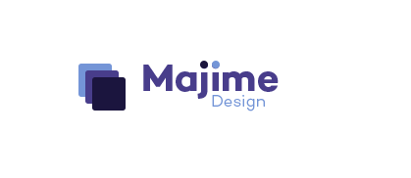



I then attempted to overlay the icons diagonally. After I decided to gradually begin to increase the amount of colours in the gradient.

**Design 4**



I kept the gradient idea with the icon but decided to combine it with the text more, almost floating it around the icon. Still allowing the icon to be recognisable on it’s own.

**Crank design & development**

I decided against the company name Majime. The main reason being it was hard for people to pronounce correctly, especially when read. I wanted to use the word crank as my company name, because it is a strong word that is easy to read and understand. I also wanted to add design and development into that logo to show what the company does. I wanted to use the accented colours used throughout my website. The colour was between purple or blue. Blue represents creativity, being imaginative and wise. Purple represents trust, being dependable and strength.[77] All of these traits are what I want the user to feel when viewing my company website.

**Design 1**



After creating this logo I thought it was too text heavy and the icon was a small percentage of the logo. This needs to be a larger part so the website can be recognised with just the logo. I decided to use a cog as the icon because a crank fits onto a cog to and make it work. The cog represents the client’s project, when placed next to the company name ‘crank’ effectively shows how the company will make the client’s project work with design and development. I was experimenting with colours and thought I wanted my accent colour to be quite a dark purple or blue.

**Design 2**



I changed the design quite drastically. I increased the prominence of the icon and made the word ‘crank’ the main word to focus on. Giving design & development the same space as the single word crank. I really liked the typography used for the word, but the icon just didn’t stand out enough for me.

**Design 3**

****I decided to add common development icons into the large icon to give the company more relevance to website design and development. I also tightened up the spacing between the text and icons and switched the colour pallet around. I was still unhappy with the icon not thinking it stood out, especially if it was on it’s own.

**Design 4**



I improved the cog icon to fit closer with the website design and development settings style icon. I reduced the amount of accent colour to just the word ‘crank’.

**Design 5**



I decided to split the cog down the middle with colour. I believed this made the logo seem more design orientated. However I still was not quite happy with the colour scheme and how much the icon stood out. I began to test various colours using this design.





**Design 6**



I decided to split the cog in half and divide it slightly. I believe this made the icon stand out well and could be used alone to represent the company. I still was unsure about the accented colour but at this point I knew I wanted to keep black in the logo.

**Design 7**



I began to change the colours around to see what it would look like. I tried making the text saying ‘crank’ black but instantly thought against it after seeing this logo design. I felt like it should be the other bit of text in black and the accented colour for the word ‘crank’. I was very close to the logo I wanted.

**Design 8 – Final design**



I decided to go with a purple for my accented colour and keep the other colour black. I felt this gave it a slick design and made it very memorable and eye catching. This colour scheme will be used on my website, the black mainly for the text and the purple will be used as an accented colour throughout.

**Crank Creations**

Crank design & development, as a company name was too long. I decided to remove the ‘design & development and replace it with ‘creations’. I believe this had better flow and impact to allow people the remember it easier.

**Design 1**



I wanted to keep the design quite similar but with a few aspects updated. The font used for this logo is now updated to Campton. I removed it from all uppercase as it had quite a harsh/intrusive feel about it. I found this design would work for a website if the logo was left/right aligned on the website. The design I am looking for needs the logo to be center.

**Design 2**



This design was catered towards a logo that would sit in the center of a website navigation. It was designed to ensure the user recognised Crank is the dominating word in the name. However I found the word creations was too thin and small. This made the logo look disproportionate.

**Design 3**



I decided to increase the font weight and size to make the logo look more proportional. I found this design to have the largest impact whilst also retaining the clean look I was trying to achieve.

## Appendix 1.2 – Layout designs

The layout of a website is very important. You need to have the user in mind during the whole process. This is to ensure the website is user friendly. Making the website user friendly is one of the most important aspects in the design process. If a user cannot operate the website as intended, then you will potentially lose clients.

One of the main problems I encountered during the design stages was the lack of content I had to fill up each page. I had to cater my designs around the limited content.

All of the images/icons that were used in the design process are temporary (except the logo) and will be replaced with unique bespoke ones for development.

**Global Sections**

**Navigation**

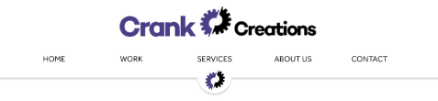

I wanted to have the navigation quite large when the user first landed on the page. This clearly allows the user to see how to navigate around the website. It also allows them to easily digest the company logo.

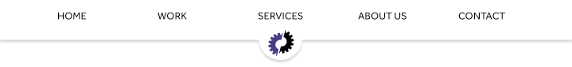

When the user starts to scroll down the page the full logo will get hidden. This is to prevent a large amount of the screen to be taken up whilst scrolling through the website. The navigation is fixed to the top of the screen but only with the short hand logo displaying below. The hide effect is done with JavaScript. It notices when the user has scrolled to a certain point on the screen and hides the full logo. When the user scrolls to the top of the page the full logo reappears.

**Footer**

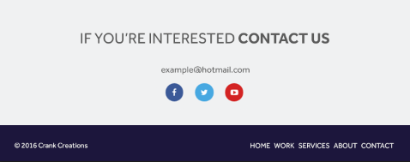

The footer is located at the bottom of each page. It is the same on every page. The footer is used to display information such as: licencing, extra navigation, social media links, contact details and a call to action. I decided to add a small navigation at the bottom to allow users to access it faster after they have read the content of a page. The ‘Contact Us’ text is hyperlinked to the contact page, to entice the user to take the first steps in communication; this is the call to action. I have chosen to use a minimalistic footer to allow the user to focus on the text I intend them to read. By keeping the text minimal, it reduces the chance the user will intentionally not read it due to time constraints.

**Homepage**

**Full page**

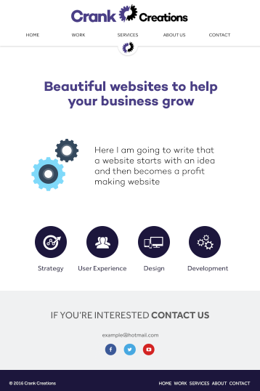

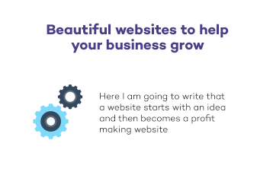

When the user first lands on the home page they initially see the title “Beautiful websites to help your business grow”. This instantly shows the user it is a website design and development company page. Below the title is an icon accompanied by a quote to show the user what they would be gaining from this service.



Just above the footer is a row of icons and headings showing the user the most important services we provide. These icons and headers are hyperlinked to take the user to the services page. When displayed on a mobile device the icons sit in a single file to make it easier to view on a small width screen.

**Work page**

**Full page**

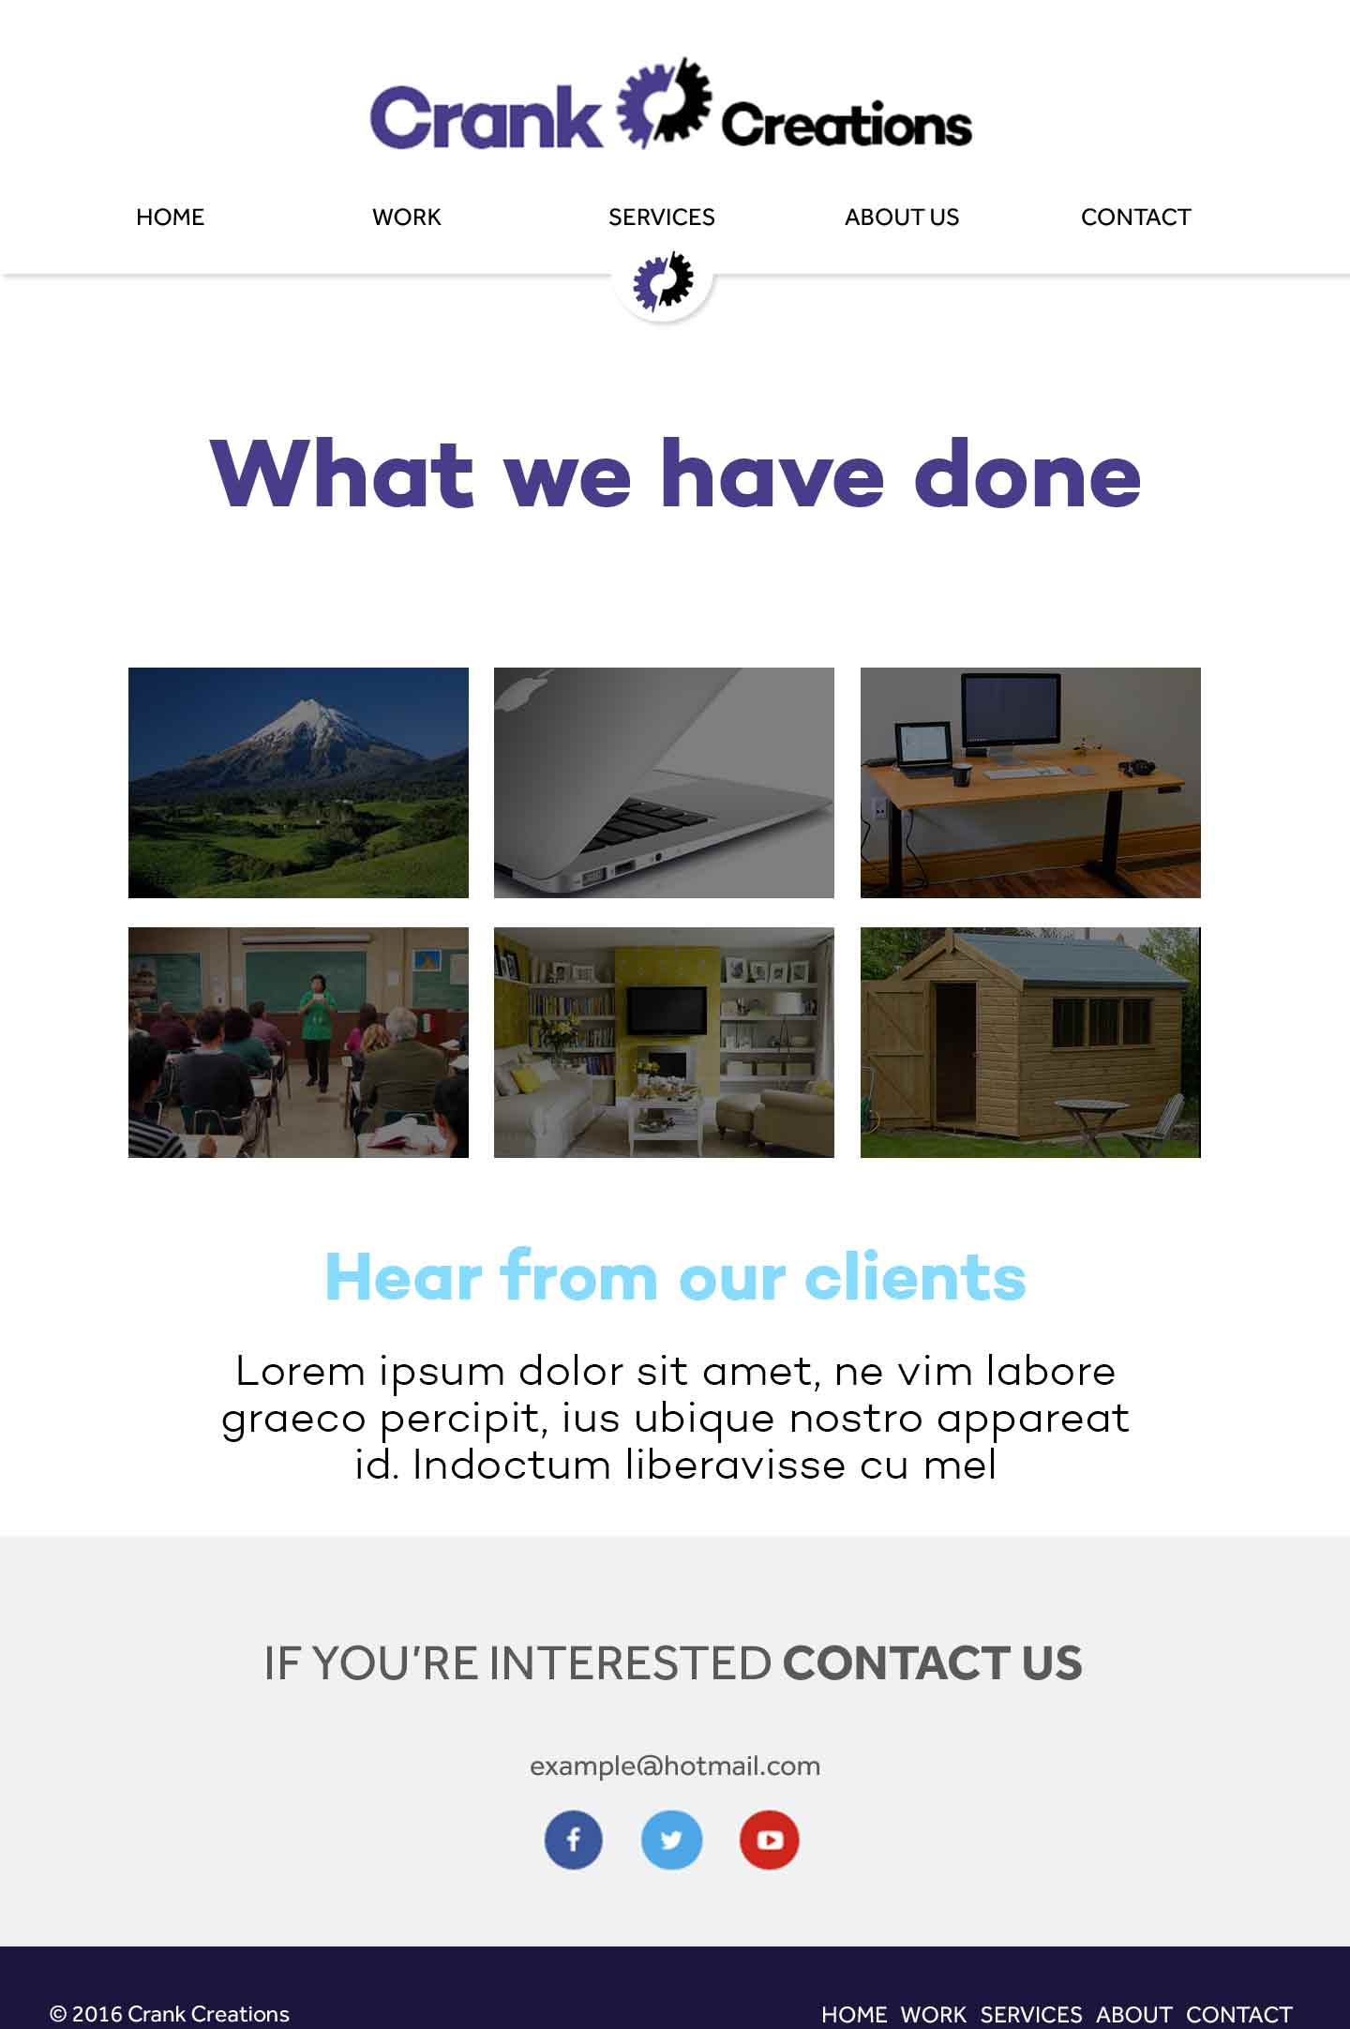

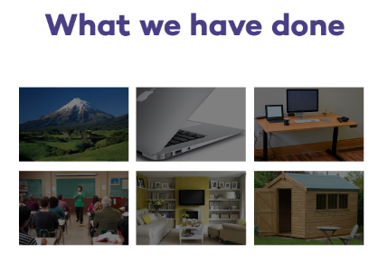

Just below the title I have organised a small thumbnail image gallery that allows the user to see an example image from the project created. These will have a hover function that will display the company name and project title. Once clicked it will take you to a stand-alone page for that specific project.

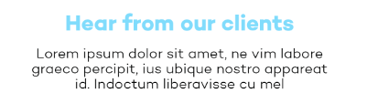

Below the project gallery will have another section showing testimonials acquired from clients previously worked with. Once I acquire more testimonials I will be able to display multiple in this section with a scrolling functionality using JavaScript.

**Services page**

**Full page**

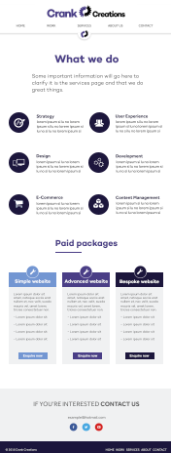

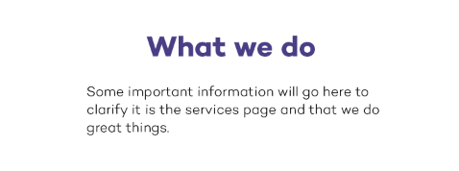

When the user lands on the services page the first bit of content they see will be a heading and sub-heading explaining what page they are on. This will allow the user to instantly understand what page they have navigated to and what they should expect to see if they continue on the page.

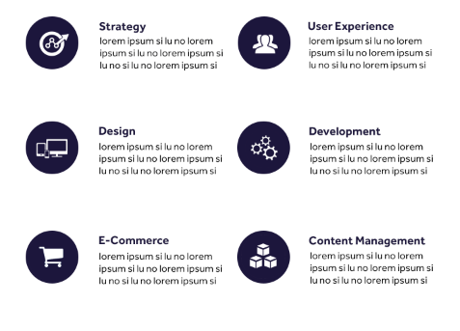

Below the title is the list of services we provide. Each service has a correlating icon and a brief description about it. When the user views the website on a mobile device it arranges the icons in a single column for easy viewing.

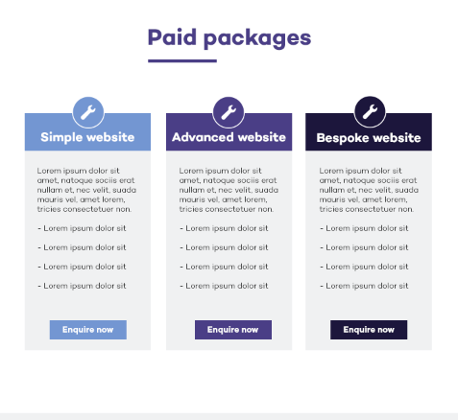

Below the list of services is a section displaying the packages a user is able to choose from. Those packages are: simple, advanced and bespoke. This gives the user a clear indication of the service they will receive, by seeing what package fits their desired website. Each package provides information to help the user select the right one. The ‘enquire now’ button will be added at a later stage. This will take the user to another page showing previously created websites from that specific package. This will help the user gain more of an understanding to what package is best suited for them.

**About page**

**Full page**

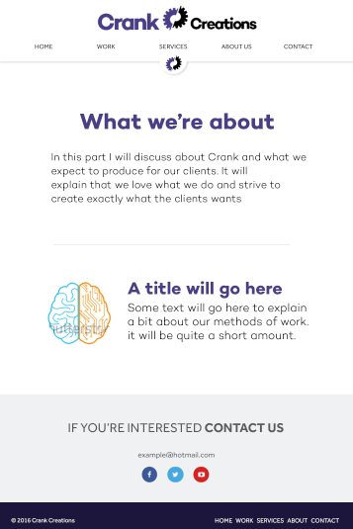

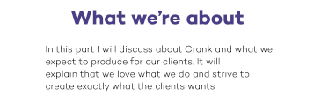

The title and sub-title on the ‘About’ page tells the user what page they have navigated to and gives a brief description about Crank as a company.

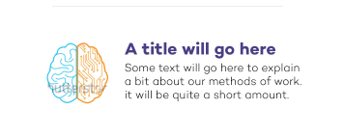

This section focuses on the company’s methods and what Crank deem as best practise in the industry. It is accompanied by a relevant image.

**Contact page**

**Full page**

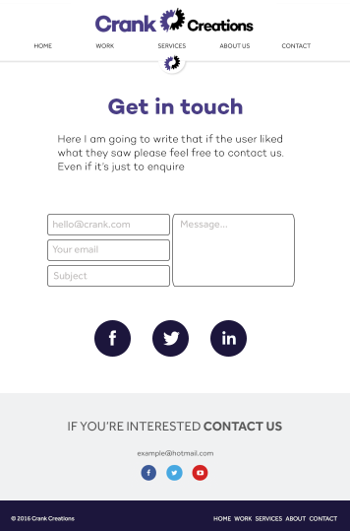

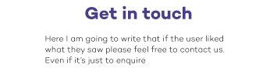

The title and sub-title of the contact page is to entice the user to contact us if they have any questions or if they would like to work with us.

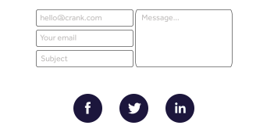

The main section on the contact page is the easy-to-use contact form that allows the user to enter their details and message into an online form that will automatically get sent to our company email. This is a process that makes it easier for the user to contact us. Below the easy-to-use contact form are icons linking to our social media websites.

## Appendix 1.3 – Illustration designs

**Homepage**

On the homepage for the Crank Creations website I creating two illustrations, one is a gif animation with css3 animation around it and the other is a static illustration.



The animated gif computer was created in Adobe Photoshop CC. It is a subtle animation of a computer turning on with the Crank Creations short hand logo coming into shot.

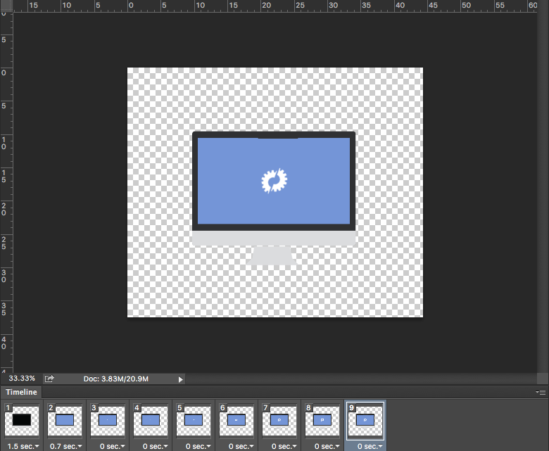

I then edited my pre-existing icons and added then into the HTML document, once added I began positioning with CSS. I then proceeded to add a CSS animation effect onto the images when the page loaded to give them a sleek reveal. This was achieved with Animate.css [78].

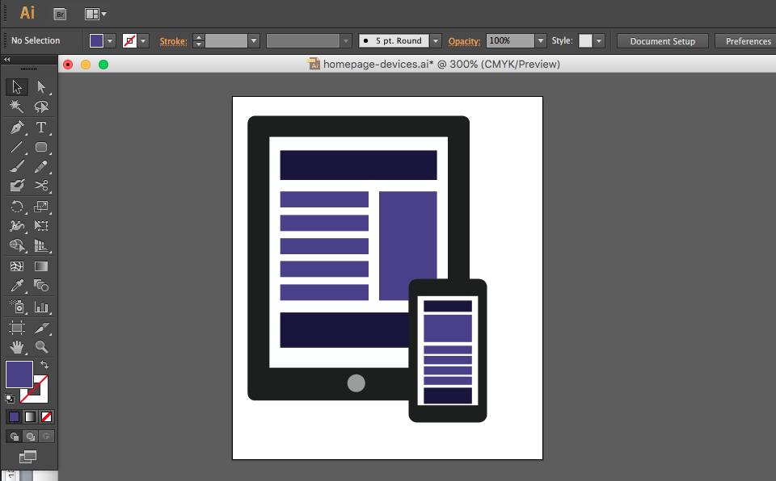

The illustration above was created in Adobe Illustrator CS6. It is a visual representation of a responsive layout that Crank Creations focus on creating with every project.

**Contact page**

On the contact page for Crank Creations I produced a simple gif animation to make the page more exciting.



The image was created in Adobe Illustrator CC [79]. The image was created entirely of shapes.

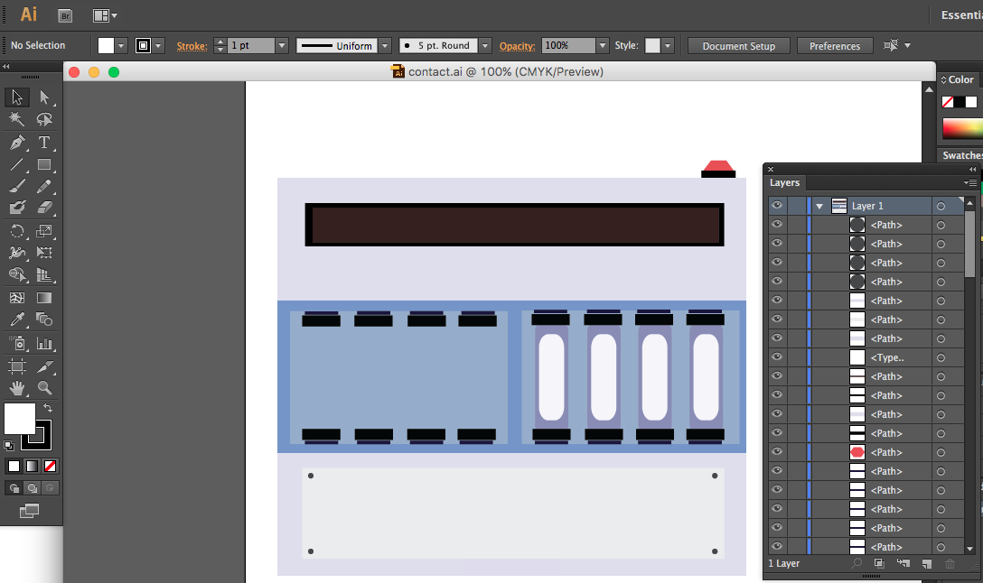

Once it was completed I then exported it into Adobe Photoshop CC [80]. Once it was exported into Photoshop I then began to create the Gif animation. The animation is 86kb in size and runs for approximately 7seconds. It is set to loop for continuous animation on the web page.

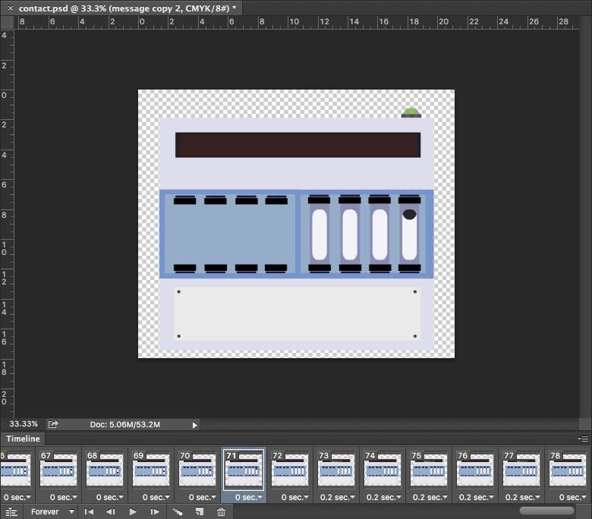

**About page**

On the About page I created two simple illustrations, one was a four sectioned cog that once clicked displayed the four key points that make up a Crank Creator. The other was a simple heart with a crank in the middle.

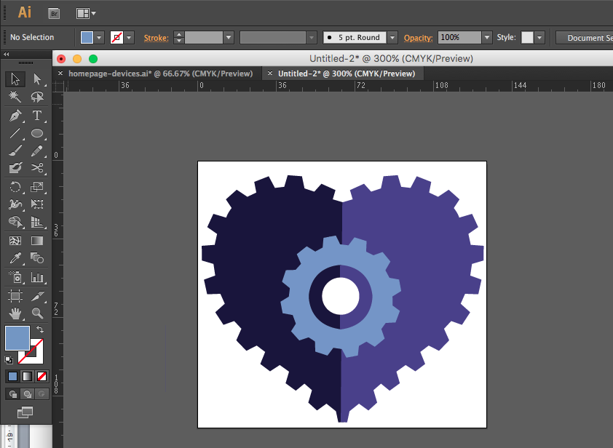

The image above was designed in Adobe Illustrator CS6 and added as a static image in the HTML.



The image was designed in Adobe Photoshop CC. It was then added into the HTML document and using JavaScript and CSS it was animated to hide and display once clicked.





The images above are a live example of the cog once clicked on the website.

# Appendix 2 – Usability test

**Executive summary**

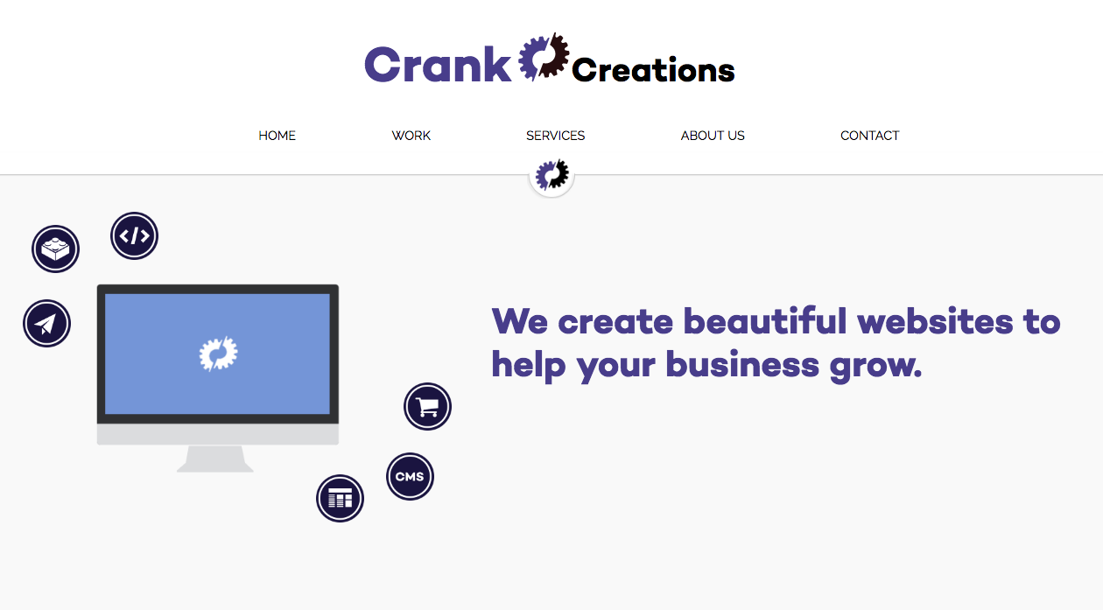

The product being testing in this report is [www.crankcreations.com](http://www.crankcreations.com). The test was conducted on the live website and the tested areas include: navigation, user experience, overall design and functionality.

The test was conducted on 4 individuals with varying ages and gender. Each participant completed a demographic questionnaire, consent & video releases form and a final feedback session to relay any information, positive or negative about the website.

**Test objective**

The overall aim of this usability test was to check the: design/functionality, user experience, content, for any errors and to gain opinions on the overall site. This was achieved by setting 5 tasks for each participant to complete based on common tasks I would expect to be done on a daily basis. Each task could be completed on desktop or mobile device; it was the choice of the participant per task to choose one. By analysing the: time taken, errors made and overall satisfaction of the journey I was able to gain a better insight into how I could improve my company website. Each test is followed by a post-test feedback sessions where participants were asked if there was anything about the site they would like to mention, whether positive or negative.

**Tasks**

I have tested each task prior to the test to create categories of time limits in which the tasks can be rated: fast, average, slow. Each task has a specific time lime stated below, if the participant fits in that bracket it would be considered an average speed. Below would be fast and above would be slow.

1. Find the packages used to help a client decide the type of website they want. **15-20 seconds**
2. Find Crank Creations philosophy. **20-25 seconds**
3. Find ‘Jem in the roughs’ individual client page. **25-32 seconds**
4. Find the form to email Crank Creations. **13-20 seconds**
5. Find and navigate to Crank Creations Facebook page. **15-20**

**Table of participants**

|  |  |  |  |  |  |
| --- | --- | --- | --- | --- | --- |
| Name | Age | Gender | How often do you use a computer? | Are you familiar with web design/ development? | If yes, what level would you class yourself? |
| Helena Mahoney | 25-40 | Female | Very often | No | N/A |
| Dominic Rathbone | 18-24 | Male | Very often | Yes | Intermediate |
| Daniela Campitelli | 18-24 | Female | Very often | Yes | Beginner |
| Matthew Lindsay | 18-24 | Male | Very often | Yes | Intermediate |

**Participant’s computing environment**

|  |  |
| --- | --- |
| **Hardware** | |
| **Computer** | Macbook Pro 13-inch, Early 2011 |
| **Software** | |
| **Operating system:** | Mac OS El Capitan 10.11.3 (15D21) |
| **Browser:** | Google Chrome Version 47.0.2526.106 (64-bit) |
| **Internet connection:** | BTHub5-6MR5 |

**Test administrator environment**

|  |  |
| --- | --- |
| **Hardware** | |
| **Computer** | Macbook Pro 13-inch, Early 2011 |
| **Mobile device** | Samsung Galaxy Ace 4 |
| **Software** | |
| **Computer operating system:** | Mac OS El Capitan 10.11.3 (15D21) |
| **Computer browser:** | Google Chrome Version 47.0.2526.106 (64-bit) |
| **Mobile operating system** | Android version 4.4.4 |
| **Mobile browser** | Google Chrome Version 4.0.3 |
| **Internet connection:** | BTHub5-6MR5 |
| **Screen Recording Program:** | QuickTime Player Version 10.1 (501.29). |
| **Face Recorder (Webcam):** | Photo Booth Version 4.0.2 (288.5) |

**Consent & video release form**

I agree to participate in the test conducted by Jamie Millman.

I understand that the participation in this test is entirely voluntary and if at any point I feel uncomfortable or unhappy with the proceeding of the test, I will make it clear to the facilitator.

I agree to be both video and audio recorded during my session.

Please sign and date below to indicate you have read and understood the information on this form and that any questions you may have had has been answered to your satisfaction.

**Signature:**

**Date:**

**Demographic questionnaire**

The demographic questionnaire was used to gain a better understanding of each participant and their computing knowledge. This was to help categorise their comments from experienced to not. Both being just as valuable as the other.

Macintosh HD:Users:jamiemillman:Documents:University Stuff:Year 3:Individual-Project:Customer Feedback - Google Forms.pdf

**Results**

The results gained from the usability test were insightful and beneficial in helping me find design inconsistencies and overall benefits to improve my company website. Each participant was asked to speak their mind to gain their thought process of each task. This was to help analyse potential errors or time constraints that may of arisen.

**Analysis by task**

**Task 1**

***“****Find the packages used to help a client decide the type of website they want.”*

None of the participants made any errors in navigating to the correct page for this task. The time taken by each participant was fast and concise. Each person achieved the task under the previously tested limit of 15-20 seconds.

Two participants separately tried to click on the short hand cog when trying to navigate back to home, expecting it to either take them to the top of the page or home. This is something I had not implemented.

**Matthew Lindsay**

**Timestamp:** 0:50 face record 1:07 screen record

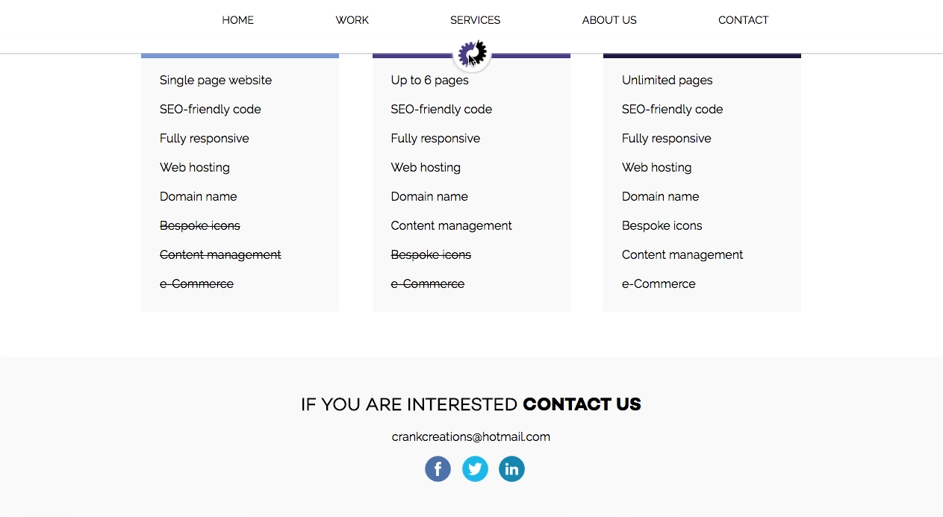

**Daniela Campitelli**

**Timestamp:** 0:57 face record 0:53 screen record

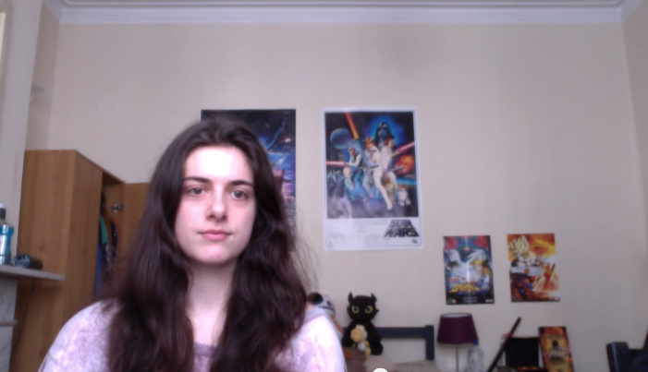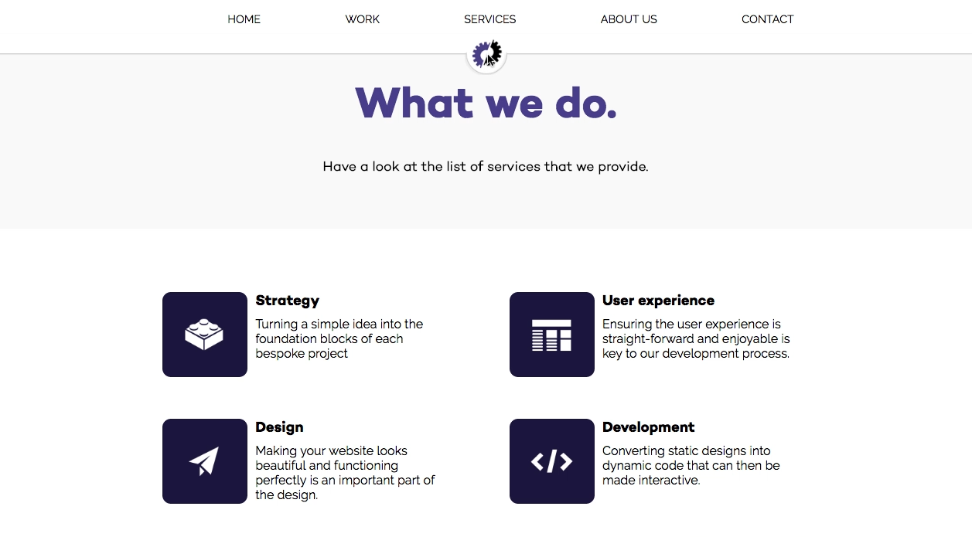

**Task 2**

*“Find Crank Creations philosophy.”*

There were no errors during this task. 3 participants completed the task in less than 20-25 seconds and 1 participant completed in 22 seconds. Making most participants a fast completion and one being average.

One participant mentioned there wasn’t mouse hover recognition when cycling over the cog. This was not automatically enabled and must be done in CSS.

**Matthew Lindsay**

**Timestamp:** 01:09 face record 01:43 screen record

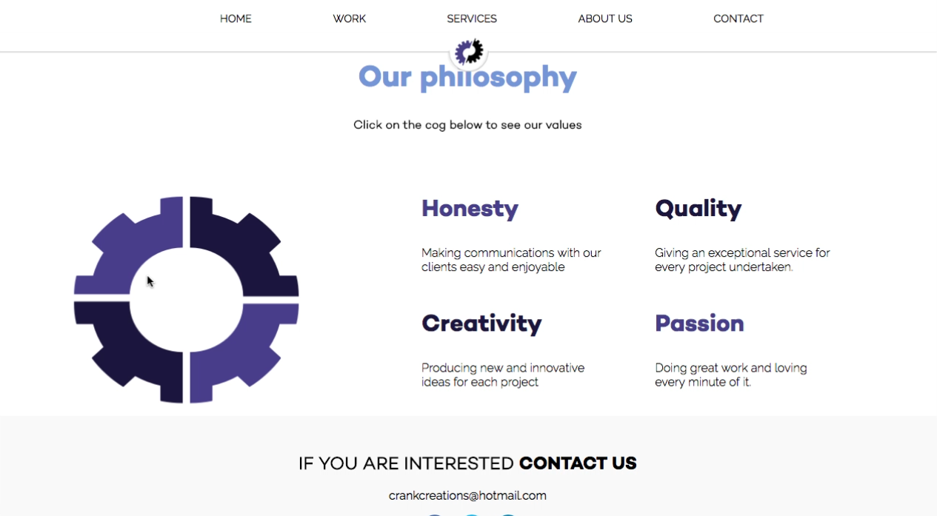

**Task 3**

*“Find ‘Jem in the roughs’ individual client page.”*

There were no errors in navigating to the selected page. Every participant successfully completed the task under 25-30 seconds.

One participant mentioned that the examples of work were not clearly labelled enough. This would cause confusion when a user is looking for a specific piece of work.

Another participant mentioned there was not enough white space for the testimonial section. This could make it hard to read the section easily.

**Dominic Rathbone**

**Timestamp:** 02:22 face record 01:58 screen record

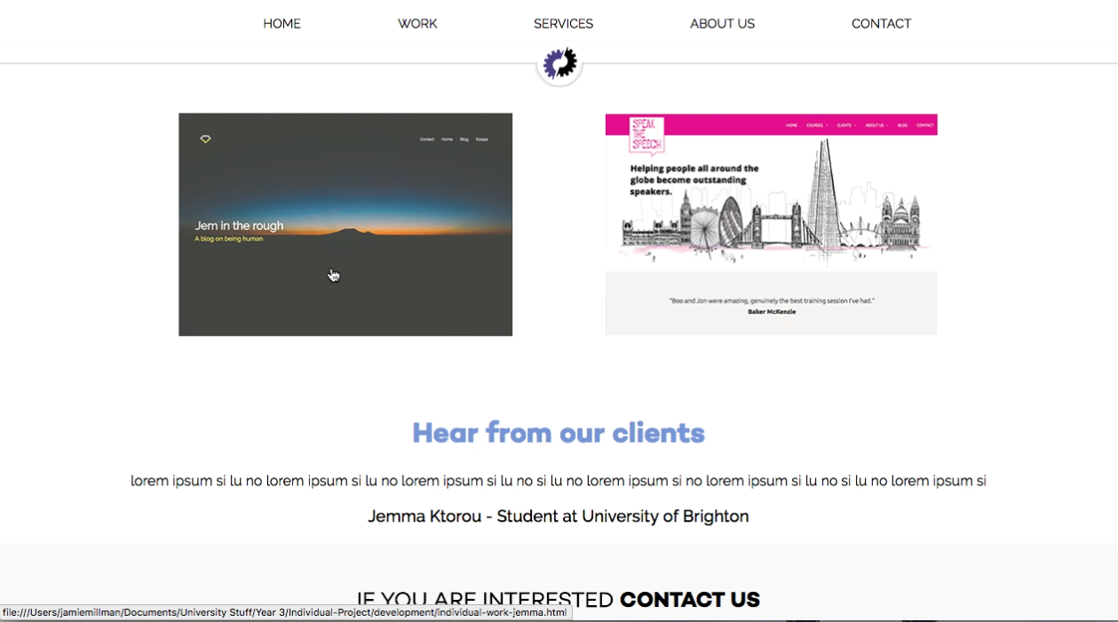

**Matthew Lindsay**

**Timestamp:** 01:31 face record

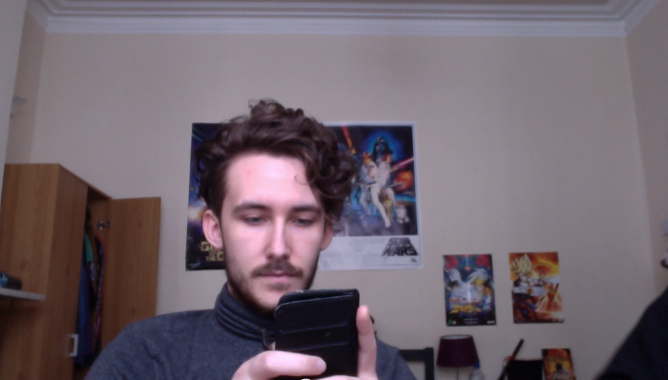

**Task 4**

***“****Find the form to email Crank Creations.”*

No errors were made during the navigation of this task. Every participant completed this faster that all the other tasks. Every participant completed it under 13-20 seconds.

One participant mentioned they believed the contact form should have been higher up on the page. Allowing the user to instantly see it when navigating to the page. This could be achieved by either reversing the form and image or aligning them side by side.

**Helena Mahoney**

**Timestamp:** 02:13 face record

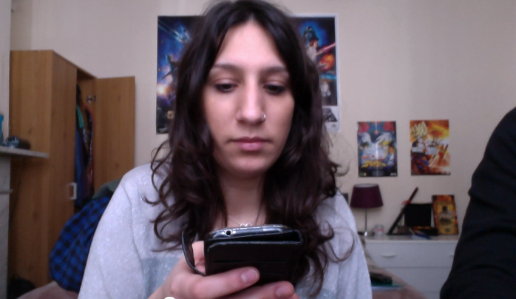

**Task 5**

*“Find and navigate to Crank Creations Facebook page.”*

2 participants navigated to the contact page to find Crank Creations facebook link. I would not consider this an error as the Facebook link is on that page, however it’s within the footer, as it is on every page. The task was completed in under 15-20 seconds by every participant.

One participant mentioned not having larger social media icons within the page. However she was unsure whether this was a bad or just different to what she was used to.

**Daniela Campitelli**

**Timestamp:** 03:12 face record

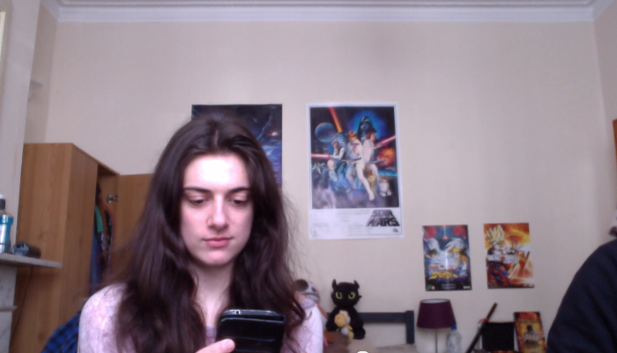

**Post-test feedback**

The feedback my website received after the tests were very beneficial. Most of the negative/recommendation feedback was stated during the tasks, however some valuable points were given after the test. Those were: having an indication of the page the user is on through the navigation, underline the ‘contact us’ in the footer to help show it’s a link, consider renaming work navigation text to be clearer and the services icons at the bottom of the homepage should not just take you to the services page but also drop your view to that section.

The positive remarks said during the post-test feedback included: great colour scheme, good logo, clean design, good amount of whitespace, great icons throughout, clean fonts and easy to navigate.

**Conclusion**

The reception received from the usability test was very positive. Points were made throughout the process of the usability test that I had either forgotten to implement or did not think to. These justified critiques helped me outline sections of my website that needed to be improved to further enhance my companie websites functionality and usability. The positive feedback reassured me that the planned decisions made in the research stages were the correct ones. This resonated through the participants structured analysis.

# Appendix 3 – Terms & Conditions

**MAKE SURE I CHECK ALL OF THESE WITH WOMBAT AND OMARS TO MAKE SURE THEY MAKE SENSE!!!**

Below is a text-only version of Crank Creations terms & conditions. The standard version is a .pdf file that gets sent to the clients email address.

**Introduction**

The following Terms & Conditions of Service apply to all products and services provided by Crank Creations. All work is carried out by Crank Creations once the client has stated they understand and agree to the Terms & Conditions.

**Project approval**

During the proposal stage Crank Creations will provide the client with their Project Proposal and Terms & Conditions. It is the client’s responsibility to have read and understood both documents. Crank Creations will only commence a project once these documents are understood and accepted by the client.

**Payment terms**

For payment terms please see your individual project proposal. All payments are to be made by bank transfer to details on the Invoice provided. At the time of the clients acceptance of the Project Proposal and Terms & conditions, a non-refundable deposit of fifty (50) per cent of the quoted fee (unless agreed otherwise) will become immediately due. Crank Creations will not begin to work on the project until this payment has been received. If the client requests additions/alterations at a later date, the fees are subject to change. The non-refundable deposit the client pays Crank Creations will be the acceptance of the Project Proposal and Terms & Conditions. The client is from then on legally bound to those documents.

**Source files**

Crank Creations are the authors and owners of the intellectual property for the design and development files, these include: psd, ai, indd, fla, html, css, JavaScript or any other source files. If a client requires these files, they will be subject to a separate quotation or ‘buy-out’ charge.

**Copyright**

Crank Creations will not use any material provided by the client that they have not obtained the proper copyright permissions to use. The client must declare they have the permission and rights to use any of the information or files that are copyrighted by a third party.

When signing the project proposal it is the clients responsibility to have guaranteed to Crank Creations that all such permission have been obtained prior to the project commencing. The Client agrees to fully indemnify and hold Crank Creations free from harm in any and all claims resulting from the Client in not having obtained all the required copyright, and/or any other necessary permission. Crank Creations may request evidence of permissions and authorities.

Any artwork, images, code or text supplied and/or designed by Crank Creations on behalf of the client, will remain the property of Crank Creations and/or it’s supplier.

**Credit**

The client must agree to allow Crank Creations to use their websites and all designs, along with a link to the client’s site on Crank Creations portfolio page and all Social Media platforms.

**Alterations**

Crank Creations cannot be held responsible for any alterations made by a third party before or after the clients project has been complete. Alterations include, but are not limited to, any changes, additions or deletions of the clients project.

**Liability**

The client is expected to send duplicated content to ensure originals are not lost or damaged. If originals or duplicates are sent, Crank Creations are not liable for the loss or damage of this content.

**Licencing**

Any design, text, illustration, idea or code created by Crank Creations for the client, or any other third party, is licenced for a single use only basis. It may not be modified, re-used or re-distributed in any way or form, without the full written consent of Crank Creations.

**Feedback**

We will always take into consideration any feedback that a client has about the project. However we must also balance accordingly the project requirement and the target audience intended for each project. If we do not act upon your feedback do not take offence, as we want to produce the best possible project to meet your requirements and goals.

**Rights of refusal**

Crank Creations will not include any text, images or other data that is deemed to be immoral, offensive, obscene or illegal. All advertising material must abide to all of the standards advised by all relevant advertising standards authorities. In the situation where any images and/or data that Crank Creations include, and subsequently discovers is in violation to such Terms & Conditions, the Client is obligated to allow Crank Creations to remove the violation without hindrance, or penalty. Crank Creations is to be held in no way responsible for any such data being included.

**Termination**

Termination of services by the client may be initially made by telephone or e-mail, however Crank Creations will need a formal notification in writing to be sent to Crank Creations postal or e-mail address. The client will be invoiced for all work completed to the date of the first termination notice and payment must be made in full within thirty (30) days.

**SEO (we do not do SEO but we make seo friendly code)**

Crank Creations do not focus on the ranking of a clients website. We produce SEO friendly code but are not responsible for managing the overall ranking of the clients website.

**Domain and hosting**

Crank Creations may purchase domain names and hosting plans on behalf of the client. However the payment and renewal is the responsibility of the client. Crank Creations are not responsible for any loss, cancellation or any other negative effect that occurs due to late or no payment.

**Default**

Invoices unpaid up to thirty (30) days from once received will turn the clients account default. For every day the clients account is default an additional charge of 10% will be added to the final amount owed (unless agreed otherwise). Clients with their accounts in default agree to pay for all expenses, including legal fees and costs for collection by third party agencies, acquired by Crank Creations to enforce these terms & conditions.

**Law**

This agreement shall be upheld and governed by English law.

**Indemnity**

Crank Creations will not allow their services to be used for any unlawful purposes. The client must agree that they will not hold Crank Creations responsible for any misuse of our services that damages you or any third party.

**STAGES STILL TO DO**

* **Proof read & Trim report –** Make it accessible to the reader
* **Alphabeticalise bibliography –** Use shortcut (google)
* **Set up as a sole trader**

1. Brighton fuse. (2011). *Brighton fuse.* Available: http://www.brightonfuse.com/. Last accessed 12th Nov 2015.
2. Wired sussex. (2015). *BUILDING BETTER DIGITAL BUSINESS TOGETHER.* Available: http://www.wiredsussex.com/. Last accessed 16th Nov 2015.
3. University of Brighton. (2015). *University of Brighton.* Available: https://www.brighton.ac.uk/index.aspx. Last accessed 16th Nov 2015.
4. University of Sussex. (2015). *University of Sussex.* Available: http://www.sussex.ac.uk/. Last accessed 16th Nov 2015.
5. National Centre for Universities and Business. (2016). *National Centre for Universities and Business.* Available: http://www.ncub.co.uk/. Last accessed 16th Nov 2015.
6. Sapsed, J & Nightingale, P. (2013). *The Brighton Fuse.* Available: http://www.brightonfuse.com/wp-content/uploads/2013/10/The-Brighton-Fuse-Final-Report.pdf. Last accessed 10th Nov 2015.
7. Wired Sussex. 2013. *Findings from The Brighton Fuse Report.* [online]. [10th Nov 2015]. Available at: https://www.youtube.com/watch?v=GgFl_R_sANw
8. University of Sussex. (2015). *Brighton Fuse 2 Project: The Role of Freelancers in the Brighton’s Creative Digital IT Cluster.* Available: http://www.sussex.ac.uk/spru/research/tim/timresearch/brightonfuse2. Last accessed 10th Nov 2015.
9. Sapsed, J. (2015). *Brighton Fuse 2: Freelancers in the Creative Digital IT Economy.* Available: http://www.brightonfuse.com/wp-content/uploads/2015/01/brighton_fuse2_online.pdf. Last accessed 10th Nov 2015.
10. LaunchSpark Video. 2013. *What is The Lean Startup?.* [Online]. [11th November 2015]. Available from: https://www.youtube.com/watch?v=_a3s0IXSuxY.
11. Eric Ries (2011). *The Lean Startup*. USA: Crown Business (USA). p1-336.
12. Built by buffalo. (2006). *Built by buffalo.* Available: http://builtbybuffalo.com/. Last accessed 2nd Dec 2015.
13. Foundation. (1998). *Foundation.* Available: http://foundation.zurb.com/. Last accessed 2nd Dec 2015.
14. Clearleft. (2015). *We design compelling digital experiences..* Available: http://clearleft.com/. Last accessed 22nd Jan 2016.
15. Aizlewood, J. (2013). *On pattern portfolios.* Available: http://clearleft.com/thinks/118. Last accessed 8th Dec 2015.
16. Ten 4. (2015). *WHAT WE DO.* Available: http://www.ten4design.co.uk/info. Last accessed 16th Dec 2015.
17. Ten4. (2015). *Ten4 Framework.* Available: https://github.com/ten4design/ten4-framework. Last accessed 2nd Dec 2015.
18. Craft cms. (2015). *Focused Content Management.* Available: https://craftcms.com/. Last accessed 2nd Dec 2015.
19. Slim. (2015). *Slim.* Available: http://www.slimframework.com/. Last accessed 8th Dec 2015.
20. Bootstrap. (2015). *Bootstrap 4 alpha.* Available: http://blog.getbootstrap.com/2015/08/19/bootstrap-4-alpha/. Last accessed 10th Dec 2015.
21. Sublime Text. (2015). *Sublime Text.* Available: http://www.sublimetext.com/. Last accessed 10th Dec 2015.
22. Brackets. (2015). *A modern, open source text editor that understands web design..* Available: http://brackets.io/. Last accessed 10th Dec 2015.
23. Modernizr. (2015). *Respond to your user’s browser features..*Available: https://modernizr.com/. Last accessed 10th Dec 2015.
24. Normalize.css. (2015). *A modern, HTML5-ready alternative to CSS resets.* Available: https://necolas.github.io/normalize.css/. Last accessed 10th Dex 2015.
25. Sass. (2006). *CSS with superpowers.* Available: http://sass-lang.com/. Last accessed 10th Dec 2015.
26. Less. (2015). *Getting started.* Available: http://lesscss.org/. Last accessed 10th Dec 2015.
27. Coffee script. (2009). *CoffeeScript is a little language that compiles into JavaScript.* Available: http://coffeescript.org/. Last accessed 10th Dec 2015.
28. Git. (2015). *Fast version control.* Available: https://git-scm.com/. Last accessed 10th Dec 2015.
29. Subversion. (2015). *Apache Subversion.* Available: https://subversion.apache.org/. Last accessed 15th Dec 2015.
30. Sass. (2006). *CSS with superpowers.* Available: http://sass-lang.com/. Last accessed 4th Dec 2015.
31. Chris Coyier. (2012). *Poll Results: Popularity of CSS Preprocessors.*Available: https://css-tricks.com/poll-results-popularity-of-css-preprocessors/. Last accessed 4th Dec 2015.
32. Gulp. (2015). *Automate and enhance your workflow.* Available: http://gulpjs.com/. Last accessed 15th Dec 2015.
33. Twitter. (2015). *960 grid system.* Available: http://960.gs/. Last accessed 15th Dec 2015.
34. Fluidable. (2015). *Fluidable.* Available: http://fluidable.com/. Last accessed 17th Dec 2015.
35. onepcssgrid. (2012). *One% CSS Grid.* Available: http://onepcssgrid.mattimling.com/. Last accessed 17th Dec 2015.
36. Drewniak, J. (2015). *Creating Your Own CSS Grid System.* Available: http://j4n.co/blog/Creating-your-own-css-grid-system. Last accessed 10th Feb 2016.
37. Jeffrey Way. (2011). *Should You Learn CoffeeScript?.* Available: http://code.tutsplus.com/articles/should-you-learn-coffeescript--net-23206. Last accessed 7th December 2015.
38. Gallagher, N. (2016). *normalize.css.* Available: http://necolas.github.io/normalize.css/. Last accessed 11th Feb 2016.
39. Gallagher, N. (2012). *About normalize.css.* Available: http://nicolasgallagher.com/about-normalize-css/. Last accessed 11th Feb 2016.
40. Erik Krieg. (2015). *pure JavaScript vs. jQuery.* Available: https://teamtreehouse.com/community/pure-javascript-vs-jquery-2. Last accessed 20th Dec 2015.
41. Pattern lab. (2015). *Pattern lab.* Available: http://patternlab.io/. Last accessed 17th Dec 2015.
42. Pew research center. (2014). *Social Networking Fact Sheet.* Available: http://www.pewinternet.org/fact-sheets/social-networking-fact-sheet/. Last accessed 10th April 2016.
43. Top 15 Most Popular Social Networking Sites. (2015). *Top 15 Most Popular Social Networking.* Available: <http://www.ebizmba.com/articles/social-networking-websites>. Last accessed 11th Dec 2015
44. Nutella. (2013). *Nutella.* Available: https://www.facebook.com/nutellauk/?brand_redir=24932281961. Last accessed 11th Dec 2015.
45. Top 15 Most Popular Social Networking Sites. (2015). *Top 15 Most Popular Social Networking.* Available: <http://www.ebizmba.com/articles/social-networking-websites>. Last accessed 11th Dec 2015
46. Eric Sornoso. (2014). *9 Small Business Twitter Marketing Examples to Study.* Available: http://www.socialmediaexaminer.com/small-businesses-twitter-marketing/. Last accessed 14th Dec 2015.
47. Top 15 Most Popular Social Networking Sites. (2015). *Top 15 Most Popular Social Networking.* Available: <http://www.ebizmba.com/articles/social-networking-websites>. Last accessed 14th Dec 2015
48. Strategyzer. (2015). *The Business Model Canvas.* Available: http://www.businessmodelgeneration.com/canvas/bmc. Last accessed 23rd November 2015.
49. Gov.uk. (2015). *Sole trader.* Available: https://www.gov.uk/business-legal-structures/sole-trader. Last accessed 8th March 2016.
50. Gov.uk. (2015). *Limited company.* Available: https://www.gov.uk/business-legal-structures/limited-company. Last accessed 8th March 2016.
51. Wired Sussex. (2016). *Get wired today.* Available: http://www.wiredsussex.com/members/. Last accessed 8th March 2016.
52. Simpson, M. (2013). *What is Professional Indemnity Insurance.*Available: https://www.know-insurance.co.uk/business/what-professional-indemnity-insurance. Last accessed 26th Jan 2016.
53. Investopedia. (2016). *Property Insurance.* Available: http://www.investopedia.com/terms/p/property-insurance.asp. Last accessed 26th Jan 2016.
54. Wipo. (2016). *What is Intellectual Property?.* Available: http://www.wipo.int/about-ip/en/. Last accessed 26th Jan 2016.
55. Chmielewski, T. (2016). *What Happens If Someone Breaks a Copyright Law?.* Available: http://smallbusiness.chron.com/happens-someone-breaks-copyright-law-55834.html. Last accessed 26th Jan 2016.
56. legislation.gov.uk. (). *Copyright, Designs and Patents Act 1988.*Available: http://www.legislation.gov.uk/ukpga/1988/48/contents. Last accessed 26th Jan 2016.
57. W3C. (2012). *Web Content Accessibility Guidelines (WCAG) Overview.*Available: https://www.w3.org/WAI/intro/wcag.php. Last accessed 29th Jan 2015.
58. Wikipedia. (2016). *User agent.* Available: https://en.wikipedia.org/wiki/User_agent. Last accessed 30th November 2015.
59. Berry, T. (2009). *What is a Business Plan?.* Available: http://articles.bplans.co.uk/writing-a-business-plan/what-is-a-business-plan/384. Last accessed 8th March 2016.
60. Griffiths, C & Crescenzo, B (2013). *My Start-up Plan*. 2nd ed. Hampshire: Harriman house LTD. p1-25.
61. Built by buffalo. (2006). *Built by buffalo.* Available: http://builtbybuffalo.com/. Last accessed 2nd Dec 2015.
62. Code 7. (2007). *A creative digital agency.* Available: http://www.code7.co.uk/. Last accessed 2nd Dec 2015.
63. Bushell, C et al.. (2014-2015). *Code 7 Reviews.* Available: https://www.google.co.uk/search?q=code+7+reviews&ie=utf-8&oe=utf-8&gws_rd=cr&ei=FaJAVu1Hga5SjIyVsAY#gws_rd=cr&lrd=0x4875855ba68e09a9:0xece3bbded965e414,1. Last accessed 9th Nov 2015.
64. Code 7. (2007). *Projects.* Available: http://www.code7.co.uk/projects/. Last accessed 2nd Dec 2015.
65. Design super. (2015). *Beautiful, easy to use websites and applications to help your business grow.* Available: http://designsuper.co/. Last accessed 2nd Dec 2015.
66. Roweena. (2015). *Roweena.* Available: http://www.roweena.co.uk/. Last accessed 2nd Dec 2015.
67. Chapman, A. (1999-2015). *pest market analysis tool.* Available: http://www.businessballs.com/pestanalysisfreetemplate.htm. Last accessed 10th Nov 2015.
68. Baseel, C. (2014). *Eight Japanese words we’d love to import into English.* Available: http://en.rocketnews24.com/2014/04/08/eight-japanese-words-wed-love-to-import-into-english/. Last accessed 4th Feb 2016.
69. Matt Siltala. (2013). *Color Emotion Guide.* Available: http://visual.ly/color-emotion-guide. Last accessed 29th Nov 2015.
70. Gregory Ciotti . (2013). *The Psychology of Color in Marketing and Branding.* Available: http://www.helpscout.net/blog/psychology-of-color/. Last accessed 30th November 2015.
71. Font fabric. (2014). *Campton free font.* Available: http://www.fontfabric.com/campton-free-font/. Last accessed 7th January 2016.
72. Font squirrel. (2015). *Webfont generator.* Available: http://www.fontsquirrel.com/tools/webfont-generator. Last accessed 7th January 2016.
73. Google. (2016). *Google Fonts.* Available: https://www.google.com/fonts. Last accessed 7th April 2016.
74. Browserling. (2016). *Live interactive cross-browser testing.* Available: https://www.browserling.com/. Last accessed 28th April 2016.
75. Speak the speech. (2016). *London based company offering training and courses throughout Europe.* Available: http://speakthespeech.co.uk/. Last accessed 29th April 2016.
76. Bee Purple. (2016). *Directory of Beepurplers’ Businesses.* Available: http://about.brighton.ac.uk/careers/enterprise/beepurplers-businesses-directory/. Last accessed 18th April 2016.
77. Matt Siltala. (2013). *Color Emotion Guide.* Available: http://visual.ly/color-emotion-guide. Last accessed 29th Nov 2015.
78. Eden, D. (2015). *Animate.css.* Available: https://daneden.github.io/animate.css/. Last accessed 31st March 2016.
79. Adobe. (2016). *Create beautiful vector art..* Available: http://www.adobe.com/uk/products/illustrator.html. Last accessed 8th April 2016.
80. Adobe. (2016). *Create anything you can imagine. Anywhere you are..*Available: http://www.adobe.com/uk/products/photoshop.html. Last accessed 8th April 2016.